BISMILLAHIR RAHMANIR RAHIM
Table of Contents
Declaration……………………………………………………………………………. i

Certificate……………………………………………………………………………...ii

Acknowledgement…………………………………………………………………… iv

Abstract……………………………………………………………………………… v

Table of Contents 1

List of Tables 5

List of Figures 6
CHAPTER 1 7
INTRODUCTION 7
1.1 Context Information 7
1.1.1 Urban Infrastructure. 8
1.1.2 Gas Infrastructure. 9
1.1.3 Fire Following Earthquake- Gas Leakage. 9
1.2 Residential Gas Supply System in Saudi Arabia. 10
1.3 Residential Gas Supply System in Kuwait. 10
1.4 Residential Gas Supply System in Japan. 11
1.4.1 City Gas 12
1.4.2 Liquefied Petroleum Gas 12
1.4.3 Earthquake Protection System (Gas) 12
1.4.4 Gas Phenomenon during an earthquake? 12
1.4.5 Gas connected to earthquake monitoring-Procedure 12
1.4.6 Gas stop after a small earthquake 13
1.4.7 Japan Gas Features. 14
1.4.8 The Difference between City Gas and Propane Gas (Japan). 14
1.5 Residential Gas Supply System in United States of America 14
1.6 Dhaka liquefaction hazard map. 15
1.7 Urban Resilience Project. 15
1.8 Widespread Building Code Violations 16
1.9 Hazardous Soil Conditions and Wetland Destruction 16
1.10 Rationale of the Paper 16
1.10.1 The Problem. 17
1.10.2 The Knowledge Gap. 17
1.10.3 The Solution. 17
1.11 Statement of the Problem 17
1.12 Research Objectives and /or Research Questions. 19
1.12.1 Broad Objective. 19
1.12.2 Specific Research Objectives 19
1.12.3 Research Question. 19
1.13 Operationalization of Key Terms/Concepts 20
1.13.1 Urban Infrastructure. 20
1.13.2 Infrastructure Security (Resilience). 20
1.13.3 Earthquake Focus (Hazard & Vulnerability). 20
1.13.4 Bangladesh Perspective 21
1.13.5 Earthquake Risk Reduction Strategy. 21
1.14 Outline of Chapters 21
1.14.1 The chapter plans are as follows: 21
CHAPTER 2 23
LITERATURE REVIEW 23
2.1 Literature Review 23
2.1.1 Bangladesh National Building Code and Infrastructure Security-Literature 23
2.1.2 Earthquake Risk Reduction Strategy Related Literature 23
2.1.3 Dhaka Infrastructure Security Risk Related Literature. 24
2.1.4 Proactive structural and administrative mitigation measures Related Literature. 24
2.1.5 Soil Condition and Liquefaction Risk-Related Literature. 25
2.1.6 Interdependency of Urban Infrastructure Systems-Related Literature 26
2.1.7 Seismic Risk Profile of Dhaka City-Related Literature 27
2.1.8 Gas Infrastructure and Fire Hazard Risks-Related Literature 28
2.1.9 Electricity Infrastructure Vulnerability-Related Literature 28
2.1.10 Water Supply and Plumbing Systems-Related Literature 28
2.1.11 Preparedness and Institutional Challenges-Related Literature 28
2.1.12 Energy Infrastructure Security-Related Literature. 28
2.1.13 Earthquake risk reduction-Related Literature. 29
2.1.14 Pre-Disaster preparedness. 29
2.1.15 Urban Planning Strategies and Policy Framework to Make Dhaka City Resilient against Earthquake 29
2.1.16 Urban Resilience Project Related Literature 30
2.1.17 Bangladesh Seismic Mega Plan- Related Literature. 31
2.1.18 Titas Gas Related Literature 31
2.2 Gaps in Past Research and Scope of further Research 35
2.3 Selected Areas of Research within the Identified Gaps. 36
CHAPTER 3 37
RESEARCH METHODOLOGY 37
3.1 Methodology. 37
3.1.1 Study Area Selection. 37
3.2 Technology Knowhow Capturing Technique 37
3.2.2 “Development of Low-Cost Methods for Monitoring and Early Warning for Geohazards” Technology 38
3.3 Data Collection 38
3.3.1 Primary Data Collection. 38
3.3.1.1 Survey Questionnaire. 38
3.3.1.2 Key Informant Interview and in-Depth Interviews. 39
3.3.1.3 Field Visit 39
3.3.1.4 Types of Interviews 39
3.3.2 Secondary Data Collection 39
3.4 Structural Model Analysis 39
3.5 Data Analysis 40
3.6 Sampling Plan for the Research 40
3.7 Research Ethics and Limitations. 40
CHAPTER 4 41
EARTHQUAKE THREAT AND POSSIBLE SCENARIOS IN DHAKA 41
4.1 Elements at Risk. 41
4.1.2 Buildings Damage in Dhaka City Corporation Area 41
4.1.3 Essential facilities Damage 41
4.2 Availability of Hospital Facilities after Earthquake in Dhaka City Corporation Area 42
4.3 Utility System Economic Loss (Millions of Dollars) 42
4.4 Earthquake Map of 50 Year Return Period (Dhaka Division) 42
4.5 Exposure Category of Population to Earthquake (Dhaka Division) 43
4.6 Risk Levels of Housing (Pucka and Semi Pucka) to Earthquake 44
CHAPTER 5 46
ANALYSIS OF DATA AND RESULTS 46
5.1 Earthquake Resistant Building/Infrastructure (Area Wise-Dhaka) 46
5.1.1 Preliminary Engineering Assessment Result 47
5.1.2 Detail Engineering Assessment Results 50
5.1.3 Seismic Hazard Analysis 53
5.1.2 Seismic Vulnerability Analysis 53
5.2 Emergency Gas Control and Management Statistics- Titas Gas 55
5.3 Structural Model Analysis 55
CHAPTER-6 57
EARTHQUAKE RISK REDUCTION STRATEGY 57
6.1 Earthquake Risk Reduction Planning Assumptions (Source: National Earthquake Contingency Plan) 57
6.2 Intended Users of the Earthquake Risk Reduction Plan 57
6.2.1 First Responder Institutions/Organization 57
6.2.2 Second Level Responder Institutions 57
6.3 Earthquake Risk Reduction Plan Implementation Strategies 58
6.4 Concept of Operations 58
6.6 Establishment of a National Emergency Operation Centre 59
6.6.1 Objectives 59
6.6.2 Organization Structure 60
6.6.3 Roles and Responsibilities of Various Desks 60
6.7 Establishment of Reporting System for Reporting the Readiness of Different Agencies 62
6.8 Virtual Earthquake Engineering University 62
6.9 Gas Sector Efficiency Improvement and Carbon Abatement Project 62
CHAPTER 7 63
DISCUSSION 63
7.1 Faults and Major Earthquake in Bangladesh 63
7.2 High Risk Areas and the Threat to Dhaka 63
7.2.1 High Risk (Zone I) 63
7.3 What is going to Happen in Dhaka 63
7.4 Major Concerns-Dhaka at Risk 64
7.5 Expert Opinions on Structures and Prevention 65
7.6 Infrastructure/Soil Condition in Dhaka if Earthquake Occurs 66
7.7 Vulnerability assessment of critical and essential infrastructures in Dhaka (Findings of the Urban Resilience Project) 71
7.8 The primary reasons identified for building vulnerability 72
7.9 Urban Planning Strategies and Policy Framework to Make Dhaka City Resilient against Earthquake 74
7.10 The Fields Where to Focus for Building Seismic Resilient City. 75
7.11 Earthquake Resistant Lifeline Utilities (Water, Gas, and Power) 77
7.12 The primary reasons identified for building vulnerability include: 77
CHAPTER 8 78
ONLINE/VIRTUAL EARTHQUAKE ENGINEERING UNIVERSITY 78
8.1 Vision 78
8.2 Operational Modalities 78
CHAPTER 9 81
CONCLUSIONS AND RECOMMENDATIONS 81
9.1 Conclusions 81
9.2 Recommendations 83
REFERENCES 85

LIST OF TABLES
Table | Title | Page
Table 1.1 | Basic Difference Between City Gas and Propane Gas (Japan) | 14
Table 2.1 | Diameter wise Gas Pipeline length across Dhaka City | 35
Table 4.1 | Recent Earthquake Damage Statistics | 41
Table 4.2 | Utility System Economic Loss | 42
Table 5.1 | The Distribution of Different Building Types in Dhaka | 46
Table 5.2 | Rapid Visual Assessment Numbers | 46
Table 5.3 | Preliminary Engineering Assessment Numbers | 47
Table 5.4 | Urban Resilient Project Summary (Category Wise) | 50
Table 5.5 | Urban Resilient Project Summary (Department Wise) | 51
Table 5.6 | Peak Ground Acceleration on the bedrock and surface for various scenarios | 53
Table 5.7 | Number and Percentage of damaged buildings for various scenarios | 54
Table 5.8 | Gas Complain Summary | 55
Table 5.9 | Gas Vigilant Operation Summary | 55
Table 7.1 | Site Classification | 66
Table 7.2 | Soil Condition in Dhaka City | 67

LIST OF FIGURES
Figure | Title | Page
Figure 1.1 | The Main Fault System in and around Bangladesh that can be Severe | 7
Figure 1.2 | Seismic Zoning Map of Bangladesh | 8
Figure 1.3 | Residential Gas System in Saudi Arabia | 10
Figure 1.4 | Gas Supply System in Kuwait | 11
Figure 1.5 | Residential Gas Supply System in Japan | 13
Figure 1.6 | Types and Features of Gas in Japan | 14
Figure 1.7 | Earthquake Behavior of Building | 18
Figure 2.1 | Impact of Earthquakes | 26
Figure 2.2 | Flow Chart of Promoting Dhaka an Earthquake Resilient City | 29
Figure 2.3 | Mega Plan | 31
Figure 2.4 | Titas Franchise Area | 32
Figure 2.5 | Digitized Layout of Gas Pipeline Network of Dhaka City Showing Diameter of Pipe | 33
Figure 2.6 | Titas Distribution Network | 34
Figure 3.1 | Station Network Map | 38
Figure 4.1 | Dhaka Division Earthquake Map of 50 Year Return Period | 43
Figure 4.2 | Exposure Category of Population to Earthquake - Dhaka Division | 44
Figure 4.3 | Risk Levels of Housing(Pucka and Semi Pucka) to Earthquake | 45
Figure 5.1 | Histogram of Construction Year | 47
Figure 5.2 | Distribution of Buildings for Types of Structural System | 48
Figure 5.3 | Concrete Strength (Mpa) of Concrete Moment Resisting Frame | 48
Figure 5.4 | Concrete Strengths (Mpa) based on the Construction Year | 49
Figure 5.5 | Distribution of Buildings based on the Function | 49
Figure 5.6 | Histogram of Deficiencies of Concrete Moment Resisting Frame | 50
Figure 5.7 | Distribution of Buildings according to Year of Construction | 51
Figure 5.8 | Number of Floor Distribution of the Buildings | 52
Figure 5.9 | Distribution of Buildings for Types of Structural System | 52
Figure 5.10 | Storey Response | 56
Figure 6.1 | Organizational Structure for National Emergency Operation Centre | 60
Figure 6.2 | Emergency Operation Centre | 61
Figure 6.3 | Roles and Responsibilities of National Emergency Operation Centre | 61
Figure 7.1 | Amplification Factor Map of Dhaka | 70
Figure 7.2 | Vision of Building Earthquake Resilient City | 75

BISMILLAHIR RAHMANIR RAHIM

URBAN INFRASTRUCTURE SECURITY FOCUSSING EARTHQUAKE: BANGLADESH PERSPECTIVE

CHAPTER 1

INTRODUCTION
The Use of Limestone Sand for the Seismic Base
Isolation of Structures
The Use of Limestone Sand for the Seismic Base
Isolation of Structures
The Use of Limestone Sand for the Seismic Base
Isolation of Structures
Ivan Banovi´

Context Information
‘SO THE EARTHQUAKE SEIZED THEM AND THEY BECAME WITHIN THEIR HOME (CORPSES) FALLEN PRONE’ (7:91). ‘…CAME AT THEIR BUILDING FROM THE FOUNDATIONS, SO THE ROOF FEL UPON THEM FROM ABOVE THEM’ (16:26). ‘WHEN THE EARTH IS SHAKEN WITH ITS (FINAL) EARTHQUAKE. AND THE EARTH DISCHARGES ITS BURDEN’ (99:1-2)
The point within the earth where earthquake waves originate is called the focus, from where the vibrations spread in all directions. They reach the surface first at the point immediately above the focus and this point is called the epicenter.
Figure 1.1 The Main Fault System in and around Bangladesh that can be Severe
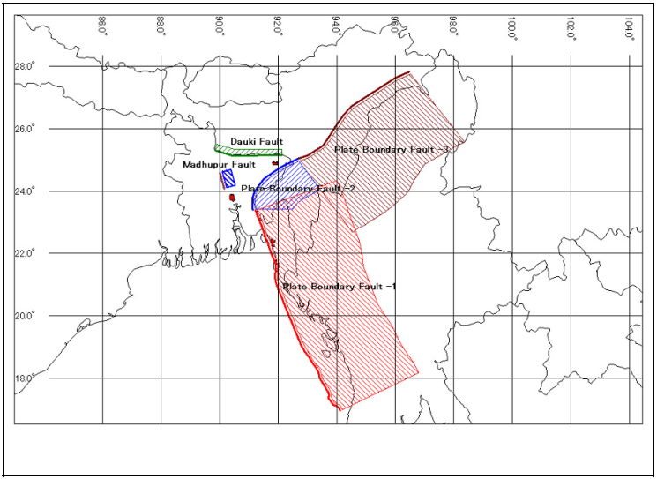
Source: Contingency Plan for Earthquake Hazard for Dhaka Power Distribution Company Limited
Bangladesh is surrounded by regions of high seismicity, which include the Himalayan Arc and Shilong Plateau in the north, the Burmese Arc, Arakan Yoma anticlinorium in the east and complex Naga-Disand-Haflong thrust zone in the northeast shown in figure 1.1. Bangladesh has four seismic zones as shown in figure 1.2. Those are low(Z=0.12), moderate(Z=0.20), severe(Z=0.28) and very severe(Z=0.36). Part of the country extended from Sylhet to Chittagong is in the high seismic zone whereas Dhaka is in the moderate seismic zone.
Figure 1.2 Seismic Zoning Map of Bangladesh
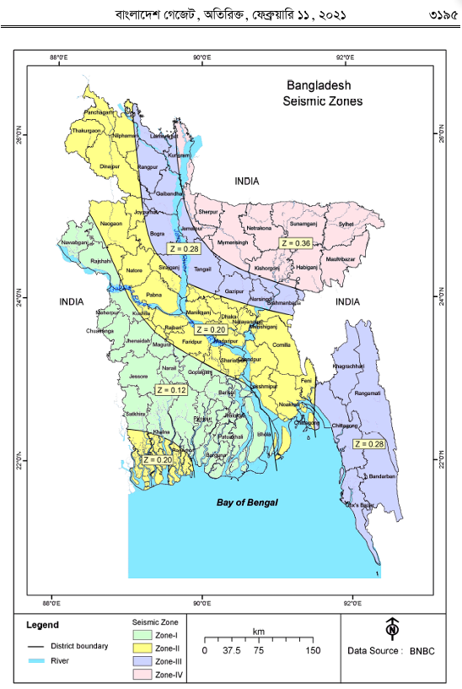

Source: Bangladesh National Building Code , 2020

Urban Infrastructure.
Urban areas are very developed, meaning there is a density of human structures, such as houses, commercial buildings, roads, bridges, and railways. Urban infrastructure mainly include airport, building, bridges, electricity, gas supply line, roads, water supply line etc. Bangladesh faces immense urban infrastructure security risks due to its position near highly active tectonic plates, including the Dauki and Madhupur fault lines. Dhaka stands as one of the world’s most seismically vulnerable megacities, where a magnitude 6.9 earthquake along the nearby Madhupur Fault could instantly collapse more than 40% to 64% of the capital’s total infrastructure. The combination of non-expert design analysis, poorly enforced building codes, soft alluvial soils, and highly volatile utility networks turns Dhaka into a severe urban infrastructure security crisis.

1.1.2 Gas Infrastructure.
Gas distribution systems are one of six broad categories of infrastructure grouped under the heading ‘lifelines’ (O’Rourke, 1998). Together with water distribution, electric power, liquid fuels, telecommunications, transportation and wastewater facilities they provide the basic services and resources upon which modem communities have come to rely, particularly in the urban context. Disruption of these lifelines through earthquake damage can therefore have a devastating impact, threatening life in the short term and a region’s economic and social stability in the long term. Bangladesh gas supply line is yet to be found earthquake resistant.
The direct effects of earthquakes are surface faulting and ground shaking. Secondary or “collateral” effects include liquefaction, landslides, densification and tsunami. Earthquake effects on buried pipelines are best understood by considering the displacements induced in the surrounding soil. Damage may he caused by transient ground deformation (GDt), or permanent ground deformation (GDp), or a combination of the two. O’Rourke (1998) defines the distinction between these two effects.
Dhaka has rigid, high-pressure underground gas pipeline systems without automated seismic shut-off valves means that structural collapses will instantly trigger city-wide secondary firestorms.

1.1.3 Fire Following Earthquake- Gas Leakage.
Fire following earthquakes due to leakage of gas has resulted in a considerable loss of property during the history. In San Francisco earthquake (1906) the estimated loss due to a widespread fire was about 250 million dollar of its time. The case of Tokyo earthquake of 1923 was much worse where the fire-induced loss shared 77% of the total. In recent times, Loma Prieta (1989), Northridge (1994) and Kobe (1995) earthquakes are new experiences in which ignition of fire was generally because of damages in old gas networks. It is therefore justifiable to concentrate on the performance of city gas networks, among other lifelines, when assessing vulnerability of urban areas to fire following an earthquake.
  - Residential Gas Supply System in Saudi Arabia.
Residential gas systems in Saudi Arabia differ significantly from many Western nations, as there is no nationwide utility grid supplying piped natural gas directly to individual homes. Instead, residential properties rely entirely on Liquefied Petroleum Gas, a mixture of propane and butane.
Figure 1.3: Residential Gas System in Saudi Arabia
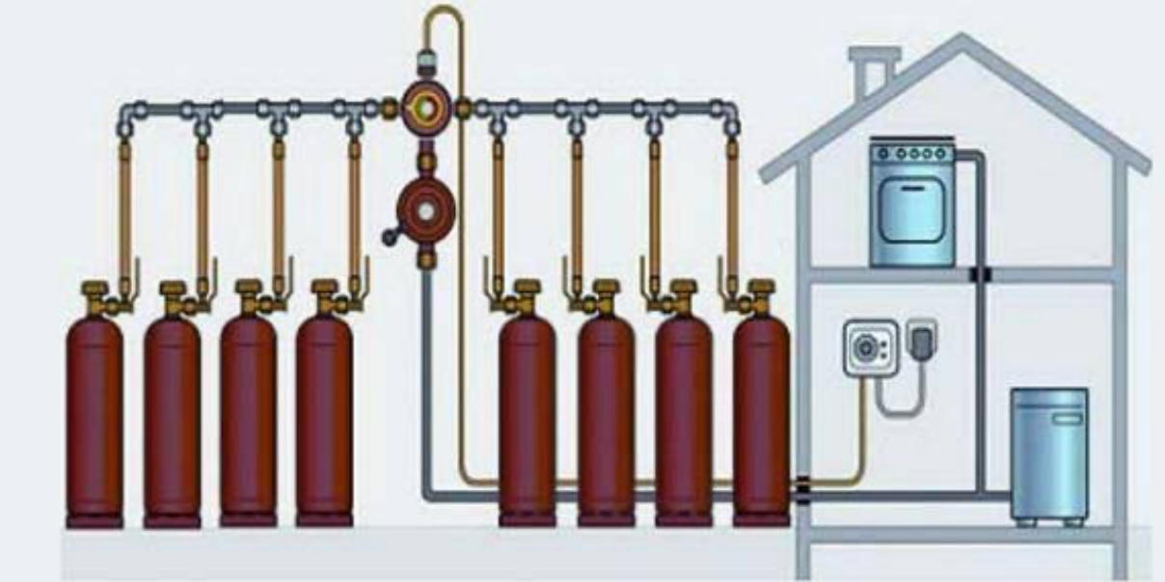
Source: Colonel Badr, Saudi Course Member
1.3 Residential Gas Supply System in Kuwait.
There is no national underground municipal natural gas grid in Kuwait, connected directly to homes for residential cooking or heating. Instead, the household gas supply system relies entirely on Liquefied Petroleum Gas , managed primary through two main distribution methods; Portable Cylinders and Centralized Piped System

Figure 1.4: Gas Supply System in Kuwait
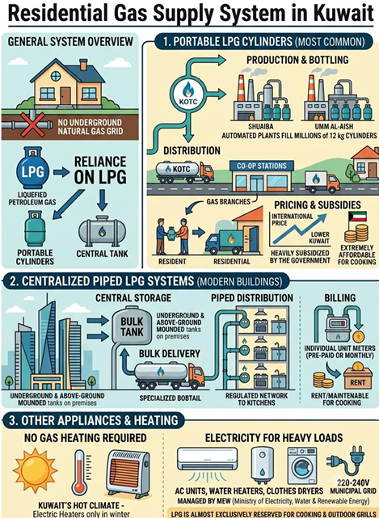
Source: Defense Attache, Kuwait
1.4 Residential Gas Supply System in Japan.
Japan has one of the safest household gas systems in the world because it is designed specifically for earthquakes. There are mainly two types of gas used in Japanese households: “city gas” and “propane gas (Liquefied Petroleum Gas). The city gas is highly earthquake resistant with polyethylene pipelines and ‘Supreme’ real time seismic monitoring system (Source: https://sj.jst.go.jp/stories/2026/s0217-01p.html,Science Technology Innovation Japan). Gas is supplied to homes in two ways including earthquake protection system.

1.4.1 City Gas
i) Delivered through underground pipelines.
ii) Common in Tokyo, Osaka, Yokohama, Nagoya, etc.

1.4.2 Liquefied Petroleum Gas
i) Stored in cylinders/tanks outside the house.
ii) Common in rural areas and smaller cities.
1.4.3 Earthquake Protection System (Gas). Every home has a smart gas meter that continuously monitors gas flow and shaking. If it detects:
i) Earthquake shaking around Japan Meteorological Agency Seismic Intensity 5 or higher.
ii) Large gas leaks.
iii) Abnormally high gas flow.
iv) Gas appliances left on for too long.
The meter automatically shuts off the gas supply.

1.4.4 Gas Phenomenon during an earthquake?
i) Earthquake occurs.
ii) Gas meter senses strong shaking.
iii) Internal valve closes automatically.
iv) Gas supply to the house stops.
v) This prevents fires and explosions from broken pipes or damaged appliances.

1.4.5 Gas connected to earthquake monitoring-Procedure
Japan’s earthquake network operated by the Japan Meteorological Agency detects earthquakes nationwide. Gas companies also have their own monitoring centers(Large Earthquake).
- Gas companies can remotely stop gas supply to entire districts.
- Pipeline pressure and damage sensors are checked.
- Engineers inspect pipelines before restoring service.

1.4.6 Gas stop after a small earthquake
Many foreign residents in Japan are surprised when their stove suddenly stops working after a quake. Often there is nothing wrong. The meter simply activated its safety function. The resident may press reset button when found no damage or no smell, after safety check is for 3 minutes, stove is turned into active mode.

Figure 1.5 Residential Gas Supply System in Japan
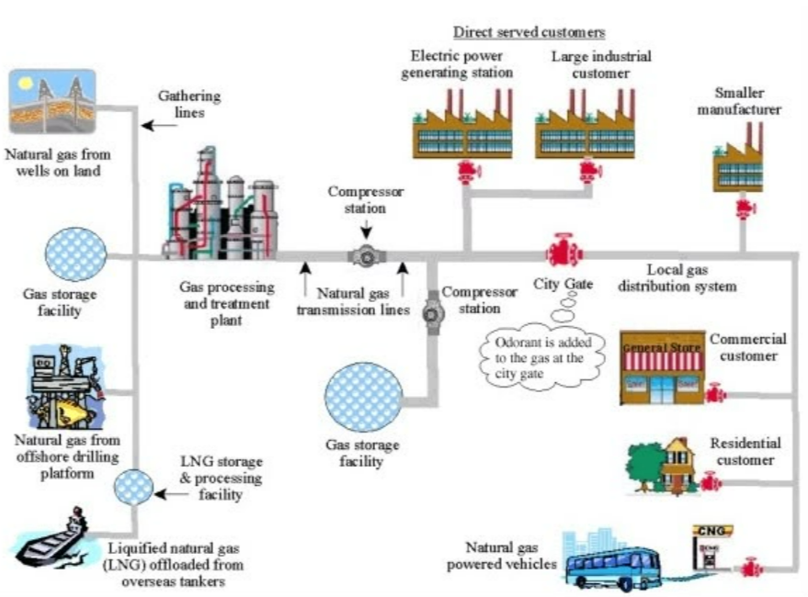
Source: Japan Philips Manager,2026

1.4.7 Japan Gas Features. The features are as follows:
Figure 1.6: Types and Features of Gas in Japan

Source: https://www.gtn.co.jp/magazine/en_us/article210/

1.4.8 The Difference between City Gas and Propane Gas (Japan). The differences are as follows:

Table 1.1: Basic Difference Between City Gas and Propane Gas (Japan)

Item | City Gas | Propane Gas (Lp Gas)
Raw Material | Natural gas (mainly methane) | Liquefied petroleum gas (mainly propane and butane)
Supply Method | Supplied through underground gas pipelines | Delivered to each household via gas cylinders
Weight | Lighter than air | Heavier than air
Heating Value | Approximately 11,000 kcal/m3 | Approximately 24,000 kcal/m3
Source: https://www.gtn.co.jp/magazine/en_us/article210/

1.5 Residential Gas Supply System in United States of America
1.5.1 A residential natural gas system is designed to safely deliver fuel from the local gas utility to the appliances that use it inside a home. Natural gas is transported through underground pipelines at relatively high pressure to neighborhoods, where it is then distributed to individual homes through smaller service lines. Before the gas enters the home, it passes through a gas meter, which measures the amount of gas consumed for billing purposes. A pressure regulator is typically installed to reduce the gas pressure to a safe level that is suitable for household appliances.
1.5.2 Once inside the home, the natural gas flows through a network of rigid black steel pipe, corrugated stainless steel tubing, or other approved piping materials. These pipes branch off to supply individual appliances such as furnaces, water heaters, stoves, ovens, clothes dryers, fireplaces, and standby generators. Each appliance is equipped with its own shutoff valve, allowing it to be isolated for maintenance or replacement without interrupting the gas supply to the rest of the house.
1.5.3 Overall, a residential gas system provides an efficient, dependable, and cost-effective source of energy for many household needs. By combining pressure regulation, secure piping, controlled combustion, modern safety devices, and proper venting, these systems deliver fuel safely throughout the home while supporting essential appliances that provide heating, hot water, cooking, and backup electrical power.

1.6 Dhaka liquefaction hazard map. A study through Rajdhani Unnayan Kotripokkho and Bangladesh University of Engineering and Technology revealed that 55% to 60% of the land within Rajdhani Unnayan Kotripokkho jurisdiction falls under high-risk “red and magenta zones” on the city’s liquefaction hazard map.

1.7 Urban Resilience Project. Dhaka has approximately 2.145 million structures. Rajdhani Unnayan Kotripokkho Urban Resilience Project data confirms that up to 95% of buildings constructed in past decades bypassed strict regulatory safety protocols or lacked approved structural designs.

1.7.1 Rajdhani Unnayan Kotripokkho has identified hundreds of structurally unstable buildings suffering from visible cracking or tilting. Out of a targeted structural audit, 42 major municipal buildings (including key academic institutions and wings of the Bangladesh Medical University/Post graduate Hospital) were ordered for immediate demolition, but yet to be completed.

1.7.2 Dhaka City faces severe structural, geological, and operational gaps regarding earthquake. Recent seismic events in the November 2025 and June 2026 moderate tremors have served as signal that the capital is dangerously exposed to a major catastrophe. An analysis of recent data from Rajuk, Bangladesh University of Engineering and Technology and urban planners reveals few critical gaps in Dhaka’s earthquake resilience:

1.8 Widespread Building Code Violations
i) Data from a 2022 Rajuk Urban Resilience Project survey indicates that 95.36% of new buildings in Dhaka were constructed (Between 2006 and 2016) without approved designs, while 90% of older structures fail to meet the Bangladesh National Building Code (Daily Sun, 21 Nov 2025).
ii) Total buildings in Dhaka are 21,45,000.
At risk of collapse are Over 8,00,000 (40%)
High-rise buildings are over 75,000 which are most built without meeting minimum standards. Between 2006 and 2016, around 95,000 buildings were constructed in the capital of which only 4,147 had Rajuk approval, meaning 95.36% were built without approved designs (Dhaka Tribune, 23 Nov 2025).
iii) Many high-rises utilize unreinforced “soft-story” ground floors (open spaces dedicated to parking), become highly susceptible to pancaking during structural shaking.

1.9 Hazardous Soil Conditions and Wetland Destruction
i) Liquefaction Risk. Rapid, uncontrolled expansion has seen wetlands and water reservoirs filled with loose earth to build housing, particularly in eastern and southwestern Dhaka.
ii) Vulnerable Zones. Joint studies by Rajdhani Unnayan Kotripokkho and Bangladesh University of Engineering and Technology could find that 55% to 60% of Dhaka falls into a high liquefaction zone. In these areas, shaking turns the filled soil behave like liquid, causing buildings to tilt or sink rapidly.

1.10 Rationale of the Paper
Urban infrastructure security focusing earthquake includes safety of total structure. The safety journey of an infrastructure starts with test, design, construction, post construction and monitoring till last. Urban infrastructure security focusing on earthquakes includes the structural retrofitting of buildings, soil-structure interaction and liquefaction mitigation, and the development of resilient “smart” utility networks. It also relies on strict land-use planning, disaster contingency plans, and structural innovations like base isolation.

1.10.1 The Problem.
Bangladesh sits near major active fault zones like the Madhupur Fault and the Dauki Fault, thereby cities like Dhaka is highly vulnerable (Khan et al., 2001).

1.10.2 The Knowledge Gap.
Current urban planning often ignores building codes (Dynamic Time History Analysis), having a high density of non-engineered buildings. Existing literature lacks proactive strategy encompassing Bangladesh National Building Code core issue including gas network vulnerabilities.

1.10.3 The Solution.
This paper illustrates earthquake resistant structural system including base isolation, Code core issue including structural/soil/gas vulnerabilities and provides an updated, data-driven proactive security strategy to minimize casualties and economic collapse.

1.11 Statement of the Problem

1.11.1 Lack of Dynamic Time History Analysis.

Dynamic Time History analysis (Earthquake resistant building structure) to be done for regular buildings with height greater than 40m in Dhaka city. Dynamic Time History Analysis is the most accurate method to simulate how real structures respond to specific earthquake ground motions over time, a lack of its application keeps a real structural risk. (Hasan,2025).

1.11.2 Lack of Soil Liquefaction Analysis.

Rapid, unplanned urbanization in Bangladesh has forced structural expansion onto highly vulnerable geological landscapes, including reclaimed wetlands and soft alluvial floodplains filled with uncompacted dredged materials. While superstructure design increasingly attempts compliance with seismic codes, there is a critical lack of comprehensive, site-specific Soil Liquefaction Analysis incorporated into foundation engineering. Standard penetration and structural design processes routinely overlook the hazard of moisture-saturated, loose silty sands transitioning into a liquid state under cyclic earthquake loading. Without integrating automated liquefaction potential mapping and depth-dependent factor-of-safety assessments into pre-construction clearance, major urban centers face severe ground failure risks. Consequently, even modern infrastructure remains highly susceptible to catastrophic tilting, differential settlement, and sudden foundation collapse during an active seismic event.

1.11.3 Critical Lifeline Infrastructures are Treated Separately.

Most existing research and policies focus primarily on structural safety of buildings, while critical lifeline infrastructures (gas, electricity, water, and plumbing) are often given proper importance (Research Question/Survey/Data). This initiates vulnerable loopholes within the infrastructure system that may lead to secondary disruption in the event of an Earthquake. For example:

Gas pipeline ruptures may trigger fires and explosions

ii) Electrical system failures can hinder emergency response

iii) Water supply disruption can affect firefighting and sanitation
1.11.4 Identification of Research Problem. The core research problem is:
Proactive measures regarding integrated earthquake infrastructure security including gas, electricity, water, building systems and liquefaction risk focusing earthquake.
Figure 1.7: Earthquake Behavior of Building
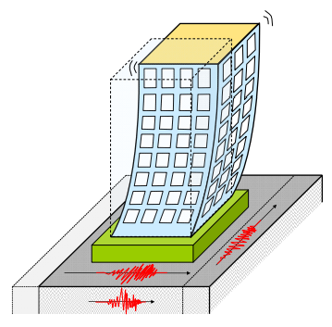
Source: www.iitk.ac.in/nicee/IITK-GSDMA

1.12 Research Objectives and /or Research Questions.
The objective of the research paper is as follows:

1.12.1 Broad Objective.
i) Broad objective is to establish a comprehensive proactive “Earthquake Risk Reduction Strategy” that is linked to an easy implementation at all levels so that “Urban Infrastructure Security” preparedness is considered early in Dhaka City.

1.12.2 Specific Research Objectives
i) To examine tasks that support earthquake risk reduction strategy such as Vulnerability Assessment of Critical and Essential Facilities, Risk Zone, Lifelines (Gas) in Dhaka city.
ii) To assess what are the damages may occur during earthquake and study the gaps, we have in Dhaka city regarding earthquake.
. iii) To evaluate Early warning systems including forecasting, dissemination of warnings, preparedness measures and reaction capacities
iv) To strengthening essential support services such as Emergency Operation Centre/Technical Support Centre.
- To deliver distant training/education program in implementing ‘Earthquake Risk Reduction Strategy (Design, Vetting, Construction, Supervision and Monitoring)’ at all levels.

1.12.3 Research Question.
The research is designed to seek the answer of subsequent questions.
- What is the most appropriate proactive measure to address the Infrastructure Security Issue focusing earthquake?
ii) What is the present state of Dhaka Infrastructure?
- What is the present state of Titas gas line?
iv) What is the present state of Dhaka soil?
- What are Earthquake education platform we have in our country?
vi) What is the gas system in few other countries?
vii) How to address vulnerable structures including gas line in Bangladesh?

1.13 Operationalization of Key Terms/Concepts

1.13.1 Urban Infrastructure.

This refers to the interconnected physical and organizational structures required to operate an urban area in Bangladesh.
- Critical Building Stock. Number of hospitals, fire stations, schools, and government headquarters.
ii) Utility Networks. Kilometers of gas pipelines, electricity grids, and water supply lines.
iii) Transportation Networks. Total length of primary roads, flyovers, metro rail tracks, and bridges.
iv) Telecommunications. Density of mobile towers and fiber-optic backbone hubs.

1.13.2 Infrastructure Security (Resilience).
This concept measures the capacity of urban systems to resist, absorb, recover from, and adapt to hazardous events.
i) Structural Integrity: Percentage of buildings compliant with the Bangladesh National Building Code.
ii) Redundancy: Availability of backup power systems, alternative evacuation routes, and secondary water sources.
- Rapidity: Estimated time (in hours or days) required to restore basic utility services after a disruption.

1.13.3 Earthquake Focus (Hazard & Vulnerability).
This defines the specific physical threat and the susceptibility of the urban environment to seismic activity.
- Seismic Hazard Zone: Location classification according to the BNBC seismic zoning map (Zone 1 to Zone 4).
ii) Soil Conditions: Liquefaction potential index of urban soils, especially in filled and in marshlands.
iii) Structural Vulnerability: Proportion of soft-story buildings, non-engineered brick structures, and buildings with visible structural distress.
iv) Spatial Density: Building footprint ratio and average width of inner-city lanes (for rescue vehicle access).

1.13.4 Bangladesh Perspective.
This contextualizes the study within the unique socio-economic, institutional, and geographic realities of Bangladesh.
i) Regulatory Compliance: Percentage of building plans approved vs. actual construction alignment through Rajuk.
ii) Institutional Capacity: Budget allocation, rescue equipment inventory, and manpower of the Fire Service and Civil Defence.
- Socio-Economic Vulnerability: Population density per square kilometer in high-risk areas (e.g., Old Dhaka) and percentage of low-income settlements.
iv) Community Preparedness: Frequency of local earthquake drills and public awareness levels regarding emergency protocols.
1.13.5 Earthquake Risk Reduction Strategy.
An earthquake risk reduction strategy aims to minimize casualties and property damage. It relies on four primary pillars: Structural Mitigation (building reinforcement), Land-Use Planning, Preparedness, and Early Warning Systems (Unesco).

1.14 Outline of Chapters

1.14.1 The chapter plans are as follows:

i) Chapter 1: Introduction

ii) Chapter 2: Literature Review

iii) Chapter 3: Research Methodology

iv) Chapter 4: Earthquake Risk Reduction Strategy

v) Chapter 5: Earthquake Threat and Possible Scenarios in Dhaka

vi) Chapter 6: Analysis of Data and Results

vii) Chapter 7: Discussion

viii) Chapter 8: Online /Virtual Bangladesh Earthquake Engineering University

ix) Chapter 9: Conclusion and Recommendation

CHAPTER 2

LITERATURE REVIEW

2.1 Literature Review

2.1.1 Bangladesh National Building Code and Infrastructure Security-Literature
Mandated through the Ministry of Housing and Public Works (2021), the Bangladesh National Building Code (BNBC) 2020 serves as the definitive legal and regulatory framework for strengthening urban infrastructure security against prevailing seismic hazards across Bangladesh. Directed at protecting public welfare, life, and property, the code establishes rigorous minimum standards for structural design, materials quality, and emergency egress, which are vital for mitigating structural collapses and facilitating rapid evacuations during an earthquake. To ensure strict systemic compliance, the document establishes the Bangladesh Building Regulatory Authority and empowers local jurisdictional Building Officials such as Rajdhani Unnayan Kartripakkha with the statutory power to execute site inspections, mandate structural tests, and issue immediate stop-work orders on non-compliant, unsafe developments. Infrastructure security is further fortified through a mandatory four-stage permit system—comprising Land Use, Large/Specialized Projects, Building, and Occupancy Certificates—which prevents unsafe occupancies and unauthorized modifications. Critically, for structural and earthquake-resilient design, the code completely eliminates informal construction oversight by dictating that sub-soil investigations, geotechnical reports, and structural design blueprints must be certified exclusively by licensed, professional civil and structural engineers with defined clinical design experience. These certified technical specialists are held directly accountable under penalty of professional blacklisting or legal prosecution for any structural lapses or false certifications. Consequently, the BNBC 2020 shifts the engineering paradigm from reactive hazard response to proactive regulatory compliance, positioning rigorous code enforcement as a foundational safeguard for the nation’s vulnerable metropolitan infrastructure.

2.1.2 Earthquake Risk Reduction Strategy Related Literature.
Moullier (2018) identify Japan’s regulatory system as a “compelling success,” highlighting its effectiveness in reducing seismic risk through robust institutional mechanisms. Key features include: (i) mandatory third-party structural review ensuring independent compliance verification; (ii) multistage inspections linked to occupancy approval;(iii) performance-based codes enabling flexible yet outcome-oriented design (Midorikawa et al.,1999); and (iv) strong professional liability that aligns practitioner incentives with regulatory compliance (Moullier et el.2018). Pedro, Meijer and Visscher (2009) classify European Union building control systems into three types-public, mixed and dual-with mixed systems predominating, typically combining public regulatory checks with private inspection roles (Pedro er al.,2009).

2.1.3 Dhaka Infrastructure Security Risk Related Literature.
Eleous and Al Noman (2025) investigate the widespread structural and systemic vulnerabilities within the Dhaka Metropolitan Area, highlighting how systemic deviations from building regulations directly compromise urban infrastructure security and heighten seismic disaster risks. The study reveals that a staggering 90% of neighborhood structures defy their authorized designs, while approximately 89% to 94.76% of constructions across key residential sectors fail foundational structural pre-requirements, dangerously undermining the city’s resilience to the region’s active seismic threats. Furthermore, the authors identify that 74.19% of local buildings actively commit setback violations to maximize financial margins. This pervasive encroachment results in exceptionally narrow roadways that inherently block the passage of emergency rescue and response vehicles, crippling the city’s post-earthquake evacuation capabilities. Systemic enforcement gaps exacerbate this vulnerability, as 46% of developers bypass occupancy evaluations by obtaining illegal utility connections, and RAJUK’s oversight wing suffers a severe 42% manpower shortage. Ultimately, the literature demonstrates that Dhaka’s expanding infrastructure remains highly insecure, necessitating strict legal accountability for deed holders and an interconnected “Shared Responsibility and Liability” framework among utilities to enforce the structural baselines mandated by the Bangladesh National Building Code.

2.1.4 Proactive structural and administrative mitigation measures Related Literature. According to Nowroz (2003), the systemic vulnerabilities and extensive disaster risks associated with earthquakes in Bangladesh require an urgent transition from reactive relief operations to proactive structural and administrative mitigation measures. The study establishes that the country’s high-density urban infrastructure is exceptionally vulnerable to catastrophic seismic shocks due to historical seismic gaps along active regional fault lines and the rapid proliferation of non-engineered, high-rise buildings. To systematically minimize potential loss of life and massive financial damage, Nowroz (2003) argues for a multi-tiered disaster management strategy. This framework mandates the rigorous updating and legal enforcement of the Bangladesh National Building Code to secure all ongoing constructions, the implementation of localized seismic monitoring networks to capture micro-tremors, and the creation of highly trained, multidisciplinary emergency response teams comprising engineers, planners, and first responders. Furthermore, the author emphasizes that widespread community-level awareness campaigns broadcast across public media are essential to reduce mass panic and ensure safe evacuation protocols, positioning integrated structural resilience and public preparedness as the foundational pillars of national infrastructure security.

2.1.5 Soil Condition and Liquefaction Risk-Related Literature.
i) Ansary and Rashid’s pioneering liquefaction susceptibility mapping, as synthesized by Anisuzzaman (2021), serves as a critical diagnostic tool for urban infrastructure security by delineating highly vulnerable, fluidization-prone zones across Dhaka’s reclaimed lowlands. By identifying these high-risk areas, the framework allows structural engineers and municipal planners to enforce targeted foundation reinforcements and soil stabilization protocols, preventing catastrophic building collapses and utility pipeline failures during a major seismic event (Anisuzzaman 2021).
ii) The geotechnical characteristics of Dhaka significantly contribute to its earthquake vulnerability. The city is predominantly built on alluvial soil and reclaimed land, which are highly susceptible to liquefaction (Rahman et al., 2020).

2.1.6 Interdependency of Urban Infrastructure Systems-Related Literature

- Ferooz (2017) in Seismic vulnerability assessment of transportation networks and lifeline infrastructure in urban centers demonstrates that earthquakes cause severe urban disruption by simultaneously damaging transportation networks and burying lifeline infrastructure, leading to structural failures and isolated sectors. The study highlights that the rupture of critical lifelines, such as gas and water lines, triggers secondary hazards that exacerbate the immediate, catastrophic damage to roadways and emergency response capabilities.
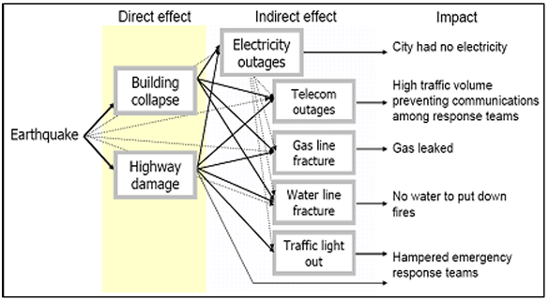
Figure 2.1 Impact of Earthquakes
Source: Contingency Plan for Earthquake Hazard for Dhaka Power Distribution Company Limited
- Xu (2021) in Cascading failures and interdependency modeling in urban utility networks during extreme hazards, mentioned that modern metropolitan areas exhibit extreme cascading vulnerabilities during disasters due to the tightly coupled interdependencies of urban utilities. A major outage in the electricity distribution system directly triggers systemic operational failures across both water pumping stations and natural gas regulation systems, effectively crippling a city’s vital lifeline infrastructure. Within the context of seismic events, this co-dependent failure mechanism severely undercuts urban infrastructure security. When an earthquake cuts local power lines, the immediate shutdown of water treatment plants and distribution networks hinders urban firefighting efforts, while unmonitored gas supply system failures elevate the risk of secondary, widespread pipeline explosions. Xu (2021) argues that evaluating infrastructure security from a single-sector perspective is no longer sufficient; instead, municipal authorities must deploy integrated, cross-sector simulation tools and decentralized emergency backup grids. By implementing these measures, cities can prevent localized electrical grid failures from cascading into complete, multi-system lifelines shutdowns, thereby safeguarding public safety during critical post-earthquake response windows.
- A key theme emerging from the literature is the interdependency of urban infrastructure systems. Buildings, gas, electricity, and water systems are interconnected, and failure in one sector can trigger cascading effects in others (Alam et al., 2018).

2.1.7 Seismic Risk Profile of Dhaka City-Related Literature

- Alam et al. (2018) in Urbanization, megacity growth, and the evolution of seismic vulnerability in Dhaka, Bangladesh, assert that Dhaka’s seismic vulnerability is significantly heightened by rapid urbanization into a megacity that has outpaced the development of resilient infrastructure. The research emphasizes that addressing these risks requires urgent, high-utility, and structural improvements to critical networks to protect the dense population during disasters.
ii) A large proportion of structures are constructed using unreinforced masonry and non-engineered reinforced concrete, both of which exhibit poor seismic performance (Alam et al., 2018).
- The prevalence of soft-story configurations further exacerbates structural instability during seismic events. Additionally, weak enforcement of the Bangladesh National Building Code has resulted in widespread non-compliance with seismic design provisions (Rahman et al., 2018).
- Bangladesh being located on the seismically active Indian plate is exposed to significant seismic risk. Earthquake Disaster Risk Index of Stanford University ranks Dhaka among the 20 cities most vulnerable to earthquake in the world (World Bank,2013).

2.1.8 Gas Infrastructure and Fire Hazard Risks-Related Literature
i) Gas infrastructure represents a major source of secondary hazards during earthquakes. Pipeline ruptures can lead to gas leakage, significantly increasing the risk of fire and explosion (Shrestha, 2015).

2.1.9 Electricity Infrastructure Vulnerability-Related Literature
i) Electricity infrastructure is highly susceptible to disruption during earthquakes due to its dependence on both structural stability and network continuity. Damage to transmission and distribution systems can result in widespread power outages and increase the likelihood of electrical fires (Alam et al., 2018).

2.1.10 Water Supply and Plumbing Systems-Related Literature
i) Water supply and sanitation systems are essential for post-disaster survival and recovery. However, Dhaka’s water infrastructure is characterized by aging pipelines, leakage, and inadequate maintenance (Islam et al., 2023).

2.1.11 Preparedness and Institutional Challenges-Related Literature
i) Despite the recognized risks, earthquake preparedness in Dhaka remains limited. Kabir et al. (2023) highlight that a significant portion of the population lacks awareness and training in earthquake response.
ii) Institutional challenges include weak coordination among key agencies such as Rajuk, Wasa, and utility service providers. The absence of a unified and integrated disaster management framework further hinders effective risk mitigation and response.
2.1.12 Energy Infrastructure Security-Related Literature. Due to the lack of a comprehensive seismic zonation map and site-specific probabilistic seismic hazard maps, the human casualty, and property losses, specifically, energy infrastructure is going to be disastrous (Sakawat , Masumur and Rabiul,2020)

2.1.13 Earthquake risk reduction-Related Literature. The task of reducing vulnerability of structures and buildings is should be the key to earthquake risk reduction (Raihanul and Nazrul, 2016).
2.1.14 Pre-Disaster preparedness. Emerging studies suggest IoT systems can monitor drainage and infrastructure in real time (Islam et al., 2024).
From an analytical perspective, the literature consistently emphasizes that structural failure is the principal cause of casualties, indicating that improving building resilience should be the foremost priority in earthquake risk reduction strategies.
2.1.15 Urban Planning Strategies and Policy Framework to Make Dhaka City Resilient against Earthquake (Reference: SATREPS-TSUIB Project- 2022) Guidebook on Towards Seismic Resilience in Dhaka City: An Urban Planning Perspective. Tokyo & Dhaka: The University of Tokyo & Housing and Building Research Institute)
Figure 2.2: Flow Chart of Promoting Dhaka an Earthquake Resilient City
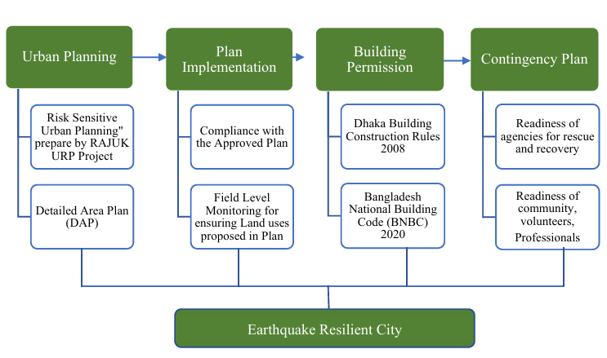
Source: SATREPS-TSUIB Project-2022

2.1.16 Urban Resilience Project Related Literature

- Under the Urban Resilience Project, Rajdhani Unnayan Kartripakkha conducted an earthquake risk assessment of Dhaka’s building stock. Findings indicated that a 6.9-magnitude earthquake along the Madhupur Fault could damage or collapse 40.3–64.8% of the city’s 2.145 million buildings (The Business Standard, 2025b). A minor tremor in 2025 damaged at least 300 buildings, including 25 partial collapses and numerous structural cracks (The Business Standard, 2025b). Only 3,252 buildings have undergone formal earthquake-safety assessments, leaving over 99.8% unverified (The Business Standard, 2025). Research on urban seismic vulnerability demonstrates that unplanned, high-density settlements on soft soil amplify earthquake damage, consistent with the situation in Dhaka (Erdik, Sesetyan, & Dogangun, 2019; Shaw & Goda, 2004).

ii. Urban Resilience Project (Rajuk), through Packages S-4 and S-5, implemented a comprehensive, multi-tiered structural assessment (RVA, PEA, DEA) of 3,252 critical buildings in Dhaka, concluding on June 30, 2022, with actionable retrofitting/reconstruction plans for 187 high-risk structures. Parallel to this, the project established a Risk-Sensitive Land Use Planning (Rslup) framework (Package S-5) incorporating Strategic Environmental Assessment (SEA) to guide future sustainable development (Bangladesh Urban Resilience Project, Technical Note 4-11 June 2024).

iii. The Rajdhani Unnayan Kartripakkha is enhancing Dhaka’s urban resilience through the Urban Resilience Project, which focuses on institutionalizing building code enforcement, establishing an Electronic Construction Permitting system, and strengthening professional accreditation. Key initiatives include the development of an Urban Resilience Unit, the implementation of the 2020 Bangladesh National Building Code, and the training of structural engineers to improve construction safety (Bangladesh Urban Resilience Project, Technical Note 4-11 June 2024).

2.1.17 Bangladesh Seismic Mega Plan- Related Literature.
i) A series of recent earthquakes felt across Dhaka and other parts of the country has prompted the government to begin policy-level discussions on developing a long-term, integrated national earthquake preparedness strategy (Business Times, Dated 14 June 2026).

ii) Officials at the Ministry of Disaster Management and Relief said the proposed framework, being informally referred to as a “mega plan,” would draw on international best practices from earthquake-prone nations and focus on
strengthening Bangladesh’s resilience against a potentially devastating seismic event (Business Times, Dated 14 June 2026).
Figure 2.3: Mega Plan
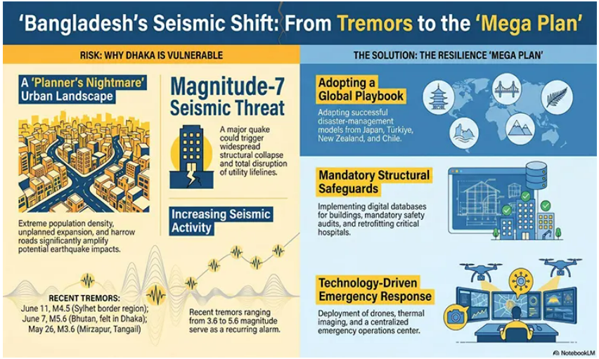
Source: Business Times, 14 June 2026

2.1.18 Titas Gas Related Literature
Lifeline earthquake engineering is relatively a new one especially in a country like Bangladesh. Usually within city pipe diameter is small and less dangerous as gas pressure is not so high. But the main distribution line beyond city having larger diameter with high pressure gas is more vulnerable to earthquake. The Titas franchise area map is shown below:
Figure 2.4: Titas Franchise Area
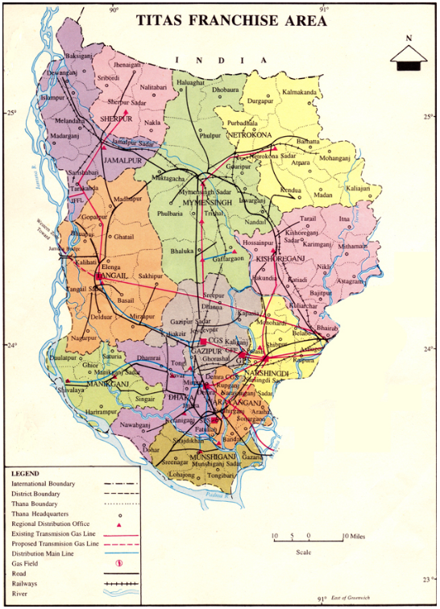
Source: Titas Gas Official Website

Figure 2.5: Digitized Layout of Gas Pipeline Network of Dhaka city Showing Diameter of Pipe
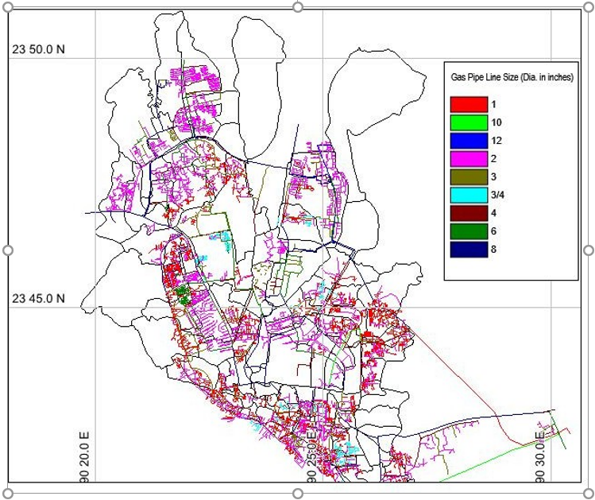
Source: Sayeed,2013

Figure 2.6 Titas Distribution Network
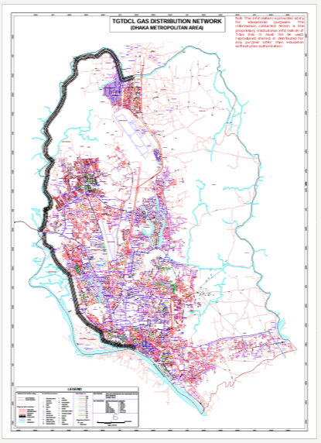
Source: Titas,2026

Table 2.1 Diameter wise Gas Pipeline length across Dhaka City
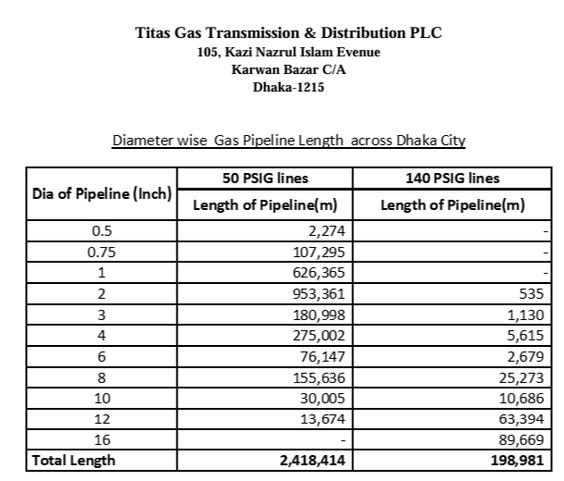

Source: Titas, 2026

2.2 Gaps in Past Research and Scope of further Research

2.2.1 Gaps in Past Research. Despite extensive research, several critical gaps remain:

i) Lack of Integrated Infrastructure Framework. Most studies focus on individual sectors (e.g., buildings, Soil liquefaction or gas systems), with limited emphasis on multi-sector integrated infrastructure security.

ii) Limited Interdependency Modeling. There is insufficient research on cascading failure mechanisms among gas, electricity, water, building systems and liquefaction risk).
- Proactive mechanism in integrated infrastructure security research is absent.

2.2.2 Scope of further Research
i) Proactive measures regarding integrated infrastructure security including gas, electricity, water, building systems and liquefaction risk focusing earthquake.

2.2.3 Methodological Bridging and Strategic Paradigm Shift
i) Ultimately, contemporary literature is limited by viewing urban seismic risks in isolation, failing to account for the cascading operational vulnerabilities of tightly coupled lifelines. It implements an integrated, exploratory, and analytical research design calibrated to the Dhaka Metropolitan Area. By triangulating qualitative and quantitative primary data, gathered through Key Informant Interviews (KIIs), field observations, and specialized questionnaire surveys, the study captures real-world institutional and systemic complexities. These field datasets are directly integrated with structural engineering tools, including site-specific Soil Liquefaction Analysis and Dynamic Time History Analysis for structures exceeding 40 meters. Consequently, this multi-tiered methodology provides the empirical foundation necessary to construct a proactive, data-driven Earthquake Risk Reduction Strategy capable of safeguarding Bangladesh’s critical urban infrastructure networks.
2.3 Selected Areas of Research within the Identified Gaps. The selected areas of identified gaps are:
i) Proactive Strategy regarding integrated infrastructure security focusing earthquake including Building, Electricity, Gas, Water etc since Dhaka has huge building deviation, uncompacted lowland liquefaction,

CHAPTER 3

RESEARCH METHODOLOGY

3.1 Methodology. The research topic ‘Urban Infrastructure security focusing Earthquake: Bangladesh Perspective’ where in research methodology an integrated research approach was adopted. The technological know-how, Data Collection, Interview, expert opinion, strategic views were gathered. The technological know-how (Base Isolation Technique) through Public Works Department including Fire Service and Civil Defense were gathered. ‘Visual Rating method for Potential Seismic Vulnerability Assessment’ of Existing Reinforced Concrete Buildings in Bangladesh was collected through Housing and Building Research Institute Bangladesh. Through this method primary data on building was collected. The data on Dhaka Urban Resilient Project through Rajdhani Unnyan Katripokkho were collected. The Earthquake Risk and Vulnerability map through Disaster Management Bureau were collected. Primary field data including Key Informant Interviews, questionnaires, and field observations is triangulated directly with empirical datasets and technical archives retrieved through key national authorities. These organizations include Professors, Bangladesh University of Engineering and Technology including Military Institute of Science and Technology, Rajdhani Unnayan Kartripakkha, the Housing and Building Research Institute, the Public Works Department and the Dhaka North City Corporation, Titas Gas, Power Grid Bangladesh, Water Supply and Sewerage Authority including Consultants . This multi-tiered approach establishes a scientifically grounded baseline to evaluate cascading failure risks across the capital’s utility networks. Ultimately, the design links engineering data directly with state-level strategic command planning. This structure provides a reliable foundation to formulate a comprehensive national Earthquake Risk Reduction Strategy.
3.1.1 Study Area Selection. Dhaka is selected as the primary case study.

3.2 Technology Knowhow Capturing Technique
3.2.1 Urban Infrastructure Security focusing Earthquake encompasses modern technology. In light of that modern technology technique could be captured. The first Base Isolation technique used in construction of Fire Service and Civil Defense build in Mirpur. This building addresses the soil, resilient gas line. Necessary technical documents could be through assistance of Armed Forces Division, National Defense College, Public Work Development including Fire Service and Civil Defense.

3.2.2 “Development of Low-Cost Methods for Monitoring and Early Warning for Geohazards” Technology. The information collected regarding the Development of low-cost methods for monitoring and early warning for earthquake which is programmed and designed through Bangladesh University of Engineering and Technology team.

Figure 3.1 Station Network Map
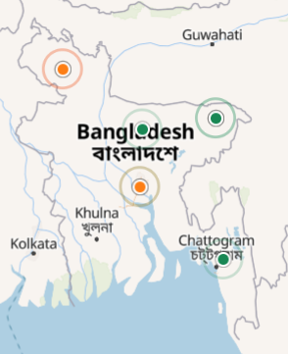
Source: https://blcasn.tech/stations/map

3.3 Data Collection

3.3.1 Primary Data Collection. Visual Rating analysis method adopted.

3.3.1.1 Survey Questionnaire. Question and Answers through experts and officials were collected.
3.3.1.2 Key Informant Interview and in-Depth Interviews. These organizations include Professors, Bangladesh University of Engineering and Technology including Military Institute of Science and Technology, Rajdhani Unnayan Kartripakkha, the Housing and Building Research Institute, the Public Works Department and the Dhaka North City Corporation, Titas Gas, Power Grid Bangladesh, Water Supply and Sewerage Authority including Consultants.

3.3.1.3 Field Visit. Field visit to Bangladesh first Base Isolation Technology Construction at Fire Service and Civil Defense Headquarter was conducted. This technology uses earthquake resilient building, gas and other services are taken care of.

3.3.1.4 Types of Interviews.
i) Formal Interviews. Formal interviews were taken of Director General, Disaster management Bureau, Chief Engineer, Public Works Department, Additional Chief Engineer, Public Works Department, Director General, House Building and Research Institute.
ii) Informal Interviews. Informal interviews were taken of Head, Civil Engineering Department, Military Institute of science and Technology, Titas gas officials, Power Grid Bangladesh Officials, Wasa Officials.
- Conversation Through Mobile. Conversation with Joint Secretary, Ministry of Disaster management and Relief, Director General and Staff officer of Armed Forces Division was held.

3.3.2 Secondary Data Collection.
i) Government Organizations were the main source of secondary data.
ii) Existing Literatures

3.4 Structural Model Analysis. Normal Structure and Base Isolation Structure model was analyzed through Etabs Software. The aim was to see time difference when real time earthquake input data is given.

3.5 Data Analysis
Data and Map collected through Government Organizations were analyzed.

3.6 Sampling Plan for the Research
The topic itself is technical. Therefore target people were professionals, Engineers, Government Officials.

3.7 Research Ethics and Limitations. The research work was conducted with maximum effort on research ethics. Necessary permission was acquired before collecting data. Necessary citing of the source was tried to be mentioned as humanly possible if otherwise not mistaken. Intentional non citation of any source was not done.

CHAPTER 4

EARTHQUAKE THREAT AND POSSIBLE SCENARIOS IN DHAKA

4.1 Elements at Risk. In the current study three different scenarios have been developed to identify the possible damage to infrastructures, buildings, transportation and number of casualties. The scenarios are least, moderate and worst case as assumed based on different magnitude of earthquake.

4.1.1 Buildings Damage in Dhaka City Corporation Area- Earthquke of 5.7 Magnitude on 21/11/2025 at 10.38 minute. Origin was in Narsingdi Zilla Madhabdi area 10 km beneath the ground.

Table 4.1 Recent Earthquake Damage Statistics

Serial | Zilla | Information | Building Damaged
01 | Dhaka | Dead 04, Injured 59 | 10
Bangladesh | Total | Dead 10, Injured461 | 50
Source: Disaster Management Bureau (Date 22/11/2025)

During an earthquake at 7.5 Mw originated from Madhupur fault, about 53,166 buildings are going to be moderately damaged. This is about 15.00 % of the total number of buildings in the city. About 72,316 buildings are going to be totally damaged during this time. If the magnitude of the earthquake is 8.0 Mw, about 34,326 buildings are going to be at least moderately damaged. During an earthquake originated from under the city at 6.0 Mw about 78,323 buildings are going to be completely damaged. An earthquake at 8.5 originated from plate boundary fault-2 is going to completely destroy 238,164 buildings.

4.1.2 Essential facilities Damage
There are going to be severe damage to essential facilities like Hospital, schools, police stations after different level of earthquakes. An earthquake at 7.5 Mw in Dhaka City, originated from Madhupur fault are going to moderately damage about 241 hospital or clinics. At the same time 10 hospitals are going to be completely damaged. About 90 schools are going to be totally damaged at the same time. 30 police stations and 4 fire service stations are going to be moderately damaged during this earthquake.

4.2 Availability of Hospital Facilities after Earthquake in Dhaka City Corporation Area

In Dhaka there are about 59,849 hospital beds available for use. On the day after an earthquake of 7.5 Mw, it is estimated that only 24,242 hospital beds (41%) will be available for use by patients already in the hospital and those injured by the earthquake. After one week, 54% of the beds will be back in service. By 30 days, 72% will be operational. After an earthquake at 8.0 Mw only about 37,625 hospital beds (63%) are available for use by patients already in the hospital and those

4.3 Utility System Economic Loss (Millions of Dollars)
Table 4.2 Utility System Economic Loss 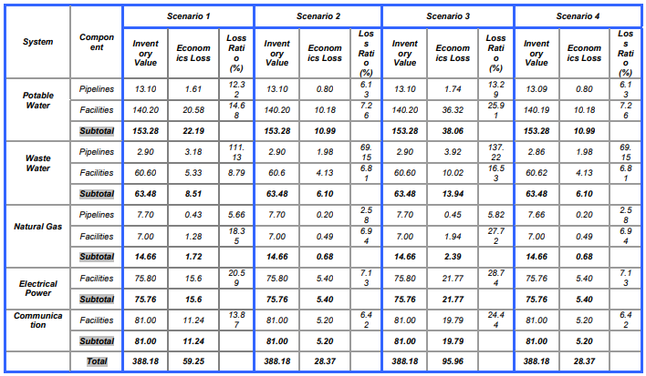 Source: Hazus calculation based on database, geology and seismic hazard

4.4 Earthquake Map of 50 Year Return Period (Dhaka Division). Earthquake hazard map of 50-year return period (Dhaka Division) is shown below:

Figure 4.1: Dhaka Division Earthquake Map of 50 Year Return Period
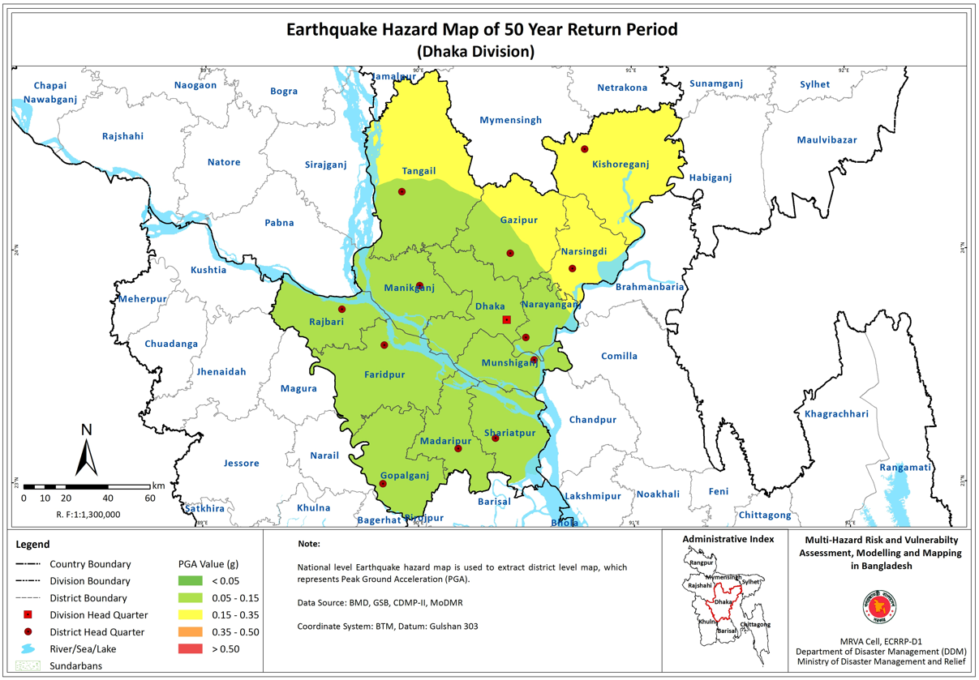
Source: Disaster Management Bureau

4.5 Exposure Category of Population to Earthquake (Dhaka Division). Exposure Category of Population to Earthquake (Dhaka Division) is shown below:

Figure 4.2: Exposure Category of Population to Earthquake- Dhaka Division
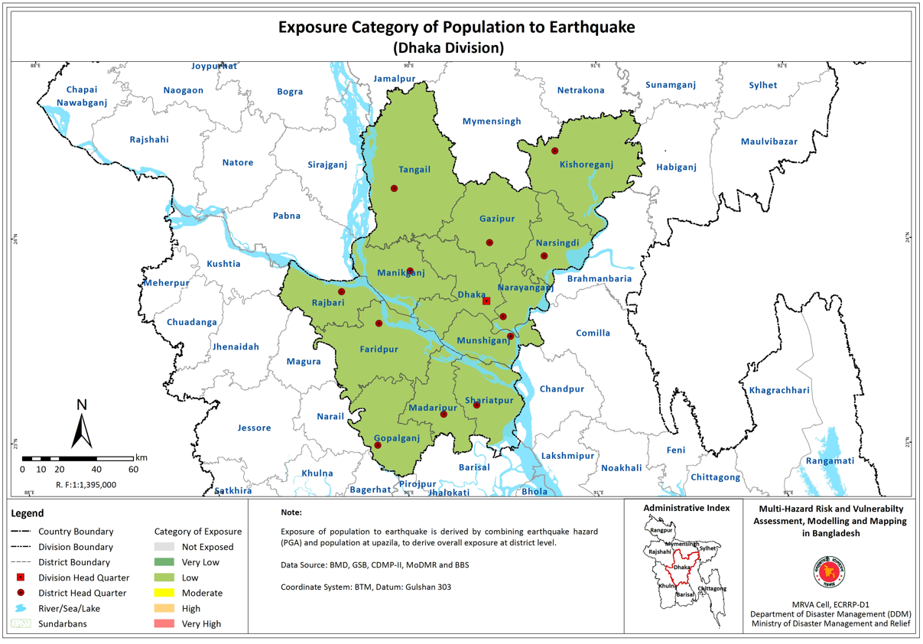
Source: Disaster Management Bureau

4.6 Risk Levels of Housing (Pucka and Semi Pucka) to Earthquake. Risk Levels of Housing (Pucka and Semi Pucka) to Earthquake (Dhaka Division)

Figure 4.3: Risk Levels of Housing (Pucka and Semi Pucka) to Earthquake
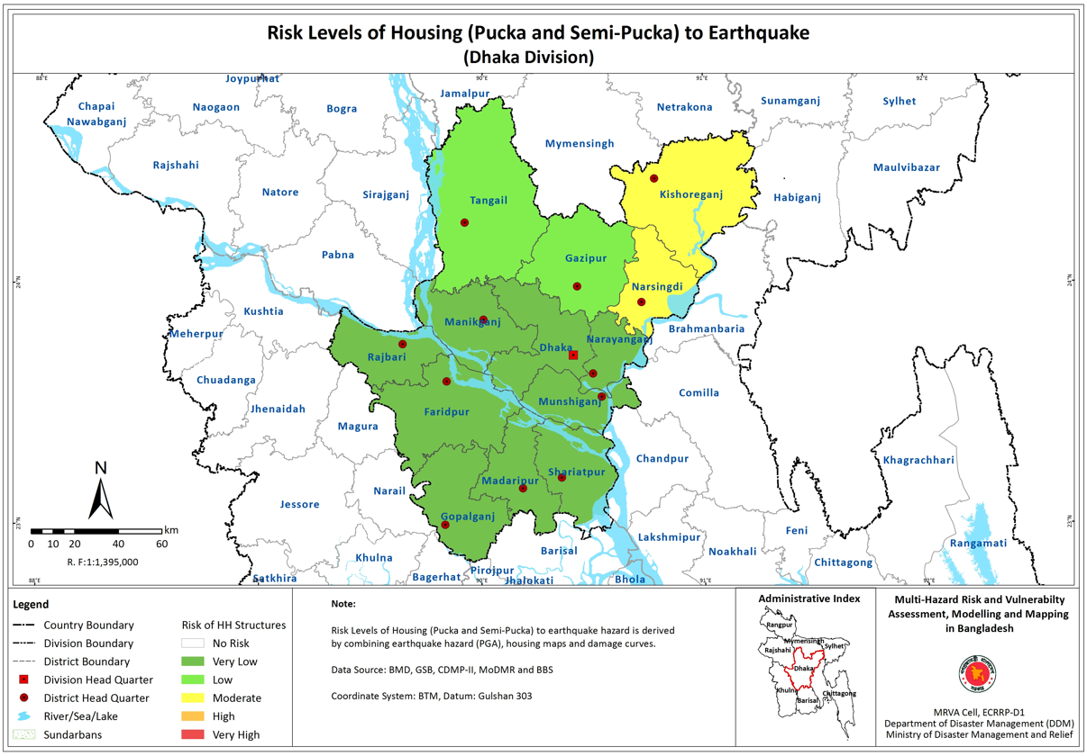
Source: Disaster Management Bureau

CHAPTER 5

ANALYSIS OF DATA AND RESULTS
5.1 Earthquake Resistant Building/Infrastructure (Area Wise-Dhaka): Can Withstand or Damage/Vulnerability Assessment and Prioritized Investment plan for Critical Assets in Dhaka

Funded through Government of Bangladesh and the World Bank in “Bangladesh Urban Resilience Project”, the consultancy firm Joint Venture of Nky (Turkey) – Protek-Yapi (Turkey) – Sheltech (Bangladesh) was appointed for consultancy on “Vulnerability Assessment and Prioritized Investment Plan for Critical Assets in Dhaka.” The consultancy firm estimated earthquake risk through Rapid Visual Assessment of 3252 number buildings, Preliminary Engineering Assessment of 579 buildings.

Table 5.1 The Distribution of Different Building Types in Dhaka
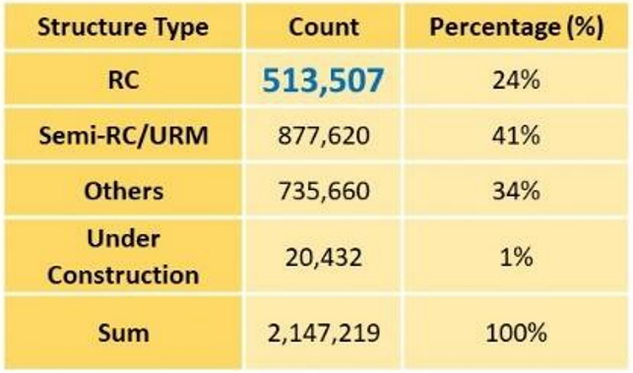
Source: Urban Resilience Project, Tech Note

The rapid visual assessment of 3252 buildings which includes schools & colleges, hospitals, police stations, other buildings also which are around 0.6% of total buildings in Dhaka Metropolitan Region.

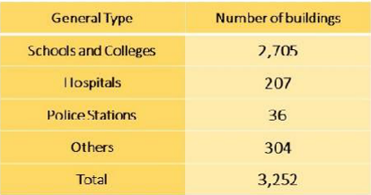
Table 5.2 Rapid Visual Assessment Numbers

Source: Urban Resilience Project, Tech Note

5.1.1 Preliminary Engineering Assessment Result
579 buildings were surveyed and assessed in the Preliminary Engineering Assessment Stage. Therefore, preliminary engineering assessment done are 17.8% of total rapid visual assessment (3352 buildings) done.

Table 5.3 Preliminary Engineering Assessment

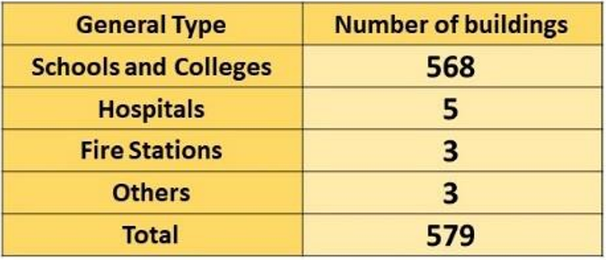
Source: Urban Resilience Project

Analysis of outcomes at this stage are demonstrated in Histogram. The age distribution of the buildings in terms of the selected benchmark years is shown in Figure 5.1. More than 51 percent of the buildings were constructed before 1996.

Figure 5.1 Histogram of Construction Year

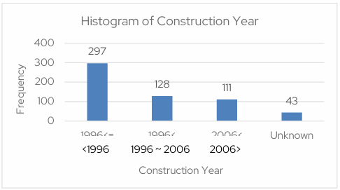

Source: Consultancy Report of Rajuk , 2022

The buildings surveyed revealed that most of the buildings are concrete moment resisting frame. About 380 buildings have reinforced concrete frame structural system, 98 buildings have unreinforced masonry structural system and 101 buildings have Dual system.
Figure 5.2: Distribution of Buildings for Types of Structural System
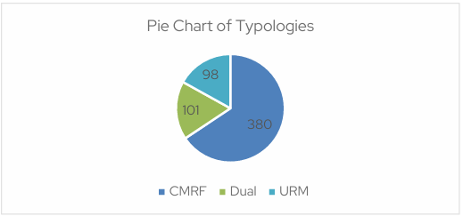
Source: Urban Resilient Project

Figure 3 depicts the concrete strength of Concrete Moment Resisting Frame buildings. As shown, more than 79% of concrete strength of Concrete Moment Resisting Frame buildings are less than 25 Mpa. In addition, less than 5% of buildings have concrete strength more than 30 Mpa.

Figure 5.3: Concrete Strengths (Mpa) of Concrete Moment Resisting Frame
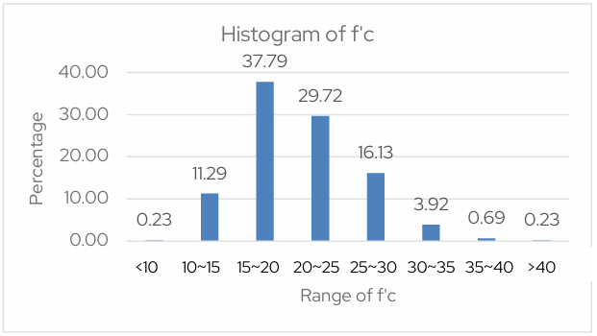
Source: Vulnerability Assessment and Prioritized Investment Plan for Critical Assets, Rajuk Final Consultancy Report, 15 June 2022
The concrete strength based on the construction year has been depicted in the following figure:
Figure 5.4: Concrete Strengths (Mpa) based on the Construction Year

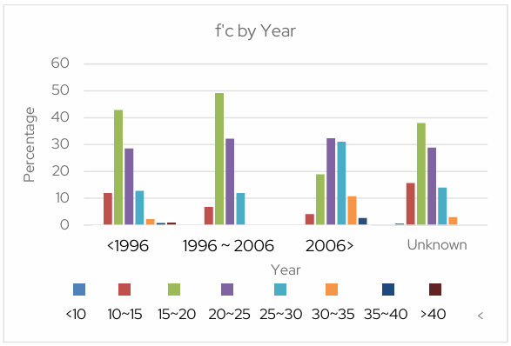
Source: Urban Resilient Project

As it can be seen the concrete strength is significantly increased after 2006.
The distribution of buildings based on the function is demonstrated in figure 5 below:

Figure 5.5: Distribution of Buildings based on the Function
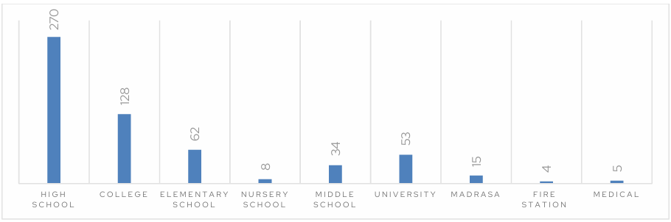
Source: Urban Resilient Project

The Histogram of most important deficiencies of Concrete Moment Resisting Frame buildings are illustrated in the following figure:

Figure 5.6: Histogram of Deficiencies of Concrete Moment Resisting Frame

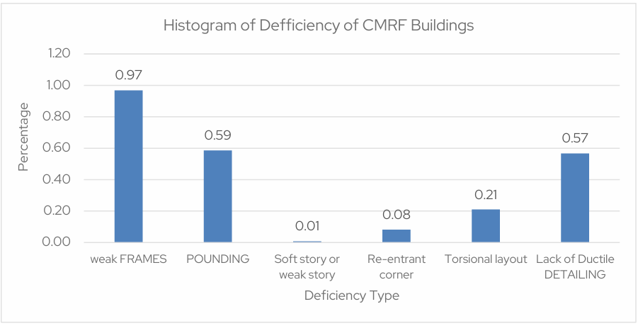
Source: Urban Resilient Project

It can be seen, most of buildings have the problems of weak frames (368 out of 380) and lack of ductile detailing (217 of 380). In addition, more than of 59% of buildings have the risk of poundings since the separation joints were not sufficient. Also, more than 21% buildings have torsional layout.

5.1.2 Detail Engineering Assessment Results
Detail Engineering Assessment of 187 buildings (School/Colleges/Universities/ Hospitals) were done which are of Government/Semi governments/Autonomous organisations which are within Dhaka Metropolitan Development Plan.

Table 5.4 Urban Resilient Project Summary (Category Wise)
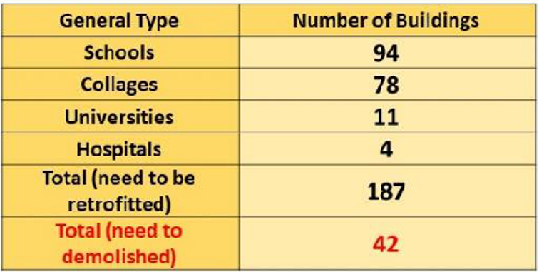
Source: Urban Resilient Project
According to the recommendation of consultancy firm 187 risky buildings were recommended for retrofitting/strengthening and 42 very risky buildings were recommended to be demolished. The risky building list is appended below(Source: Rajuk):
Table 5.5 Urban Resilient Project Summary (Department Wise)
Sl. No. | Organization | Strengthening | To be  Demolished
1 | Bsmmu | – | 3
2 | Institute of leather Engineering and Technology | 3 | –
3 | Jogonnath University | – | 4
4 | Department of Health Engineering | 4 | –
5 | Madrasa Board | 6 | 1
6 | Directorate of Primary Education | 10 | 1
7 | Jahangirnagar University | 10 | 3
8 | Education Engineering Department | 154 | 30
9 | Total | 187 | 42
Source: Urban Resilient Project

The age distribution of the 187 risky buildings in terms of the selected benchmark years is presented in Figure below. 64 buildings were constructed before 1993, 66 buildings were constructed between 1993 till 2006 and about 57 buildings were constructed after 2006.
Figure 5.7: Distribution of Buildings according to Year of Construction
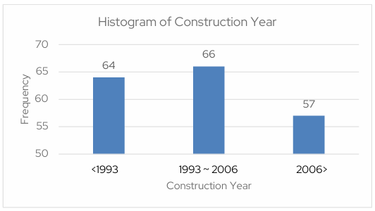
Source: Urban Resilient Project
The building statistics in terms of number of stories are displayed in Figure 8. The majority buildings are of less than 6 stories (more than 87% buildings). 25 buildings out of 187 buildings, have more than 6 stories. This indicates most of the buildings are low- to mid-rise.
Figure 5.8: Number of Floor Distribution of the Buildings
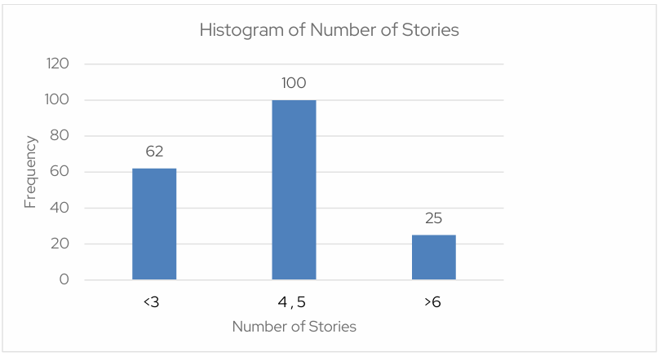
Source: Urban Resilient Project
The buildings surveyed revealed that most of the buildings are concrete moment resisting frame. Among 187 buildings 162 buildings have reinforced concrete frame structural system, 2 buildings have unreinforced masonry structural system and 23 buildings have Mixed system (Concrete moment resisting frame + unreinforced masonry)
Figure 5.9: Distribution of Buildings for Types of Structural System
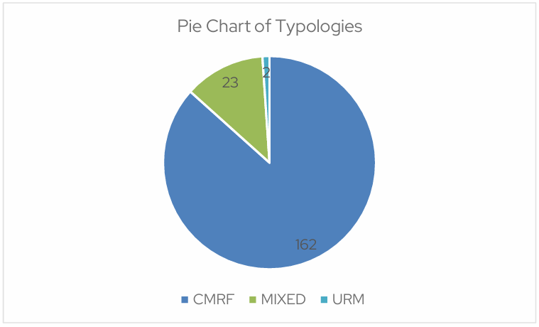
Source: Urban Resilient Project

In the Detail Evaluation Analysis stage buildings are assessed for two performance levels. In this regard, for educational facilities, the vulnerability assessment of the structures is carried out for Damage Control and life safety performance levels, against an earthquake with 475 years and 2475 years return, respectively. For the health care facilities, the vulnerability assessment of the structures is carried out for immediate occupancy and Damage Control performance levels, against an earthquake with 475 years and 2475 years return, respectively.

5.1.3 Seismic Hazard Analysis
A comprehensive seismic hazard/vulnerability analysis was performed for Dhaka Metropolitan Region under the Urban Resilience Project. An investigation into the structural geology regime indicates that the interaction between plates had formed a compressional regime in the region. After understanding the structural geology regime affecting Dhaka Metropolitan Region, the detail analysis was done within 300-km radius of Dhaka Metropolitan Region and potential seismic sources (faults) were identified.
According to the scenario-based Seismic Hazard Analysis, the worst-case scenario in the study area is related to the Madhapur fault (a segment of Jamuna fault with a maximum magnitude of 6.9.
The summary of estimated Peak Ground Acceleration on the bedrock and surface for various scenarios are presented:

Table 5.6 Peak Ground Acceleration on the bedrock and surface for various scenarios

Seismic Hazard Level/ Case |  | Scenario Magnitude | PGA (g) on seismic bedrock | PGA (g) on surface
PSHA | 50 years |  | 0.032-0.047 | 0.05-0.10
 | 75 years |  | 0.044-0.066 | 0.07-0.14
 | 100 years |  | 0.056-0.082 | 0.088-0.18
 | 200 years |  | 0.089-0.130 | 0.14-0.29
 | 475 years |  | 0.141-0.192 | 0.18-0.41
 | 2475 years |  | 0.325-0.455 | 0.37-0.63
 | 10000 years |  | 0.613-0.800 | 0.67-1.21
Scenario- Based | Chittagong Coastal Fault (segment 1) | 7.2 | 0.058-0.100 | 0.074-0.186
 | Chittagong Coastal Fault (segment 2) | 6.8 | 0.035-0.061 | 0.045-0.117
 | Dauki Fault (central segment) | 7.6 | 0.044-0.069 | 0.06-0.14
 | Dauki Fault (eastern segment) | 7.1 | 0.030-0.042 | 0.04-0.08
 | Dauki Fault (easternmost segment) | 6.6 | 0.019-0.025 | 0.025-0.05
 | Dauki Fault (western segment) | 7.4 | 0.041-0.065 | 0.055-0.13
 | Jamuna Fault | 6.5 | 0.038-0.084 | 0.05-0.177
 | Madhapur Fault | 6.9 | 0.084-0.680 | 0.115-0.9
 | Kaladan Fault 1 (first segment) | 7.1 | 0.027-0.035 | 0.034-0.07
 | Kaladan Fault 2 (second segment) | 7.3 | 0.030-0.039 | 0.038-0.08
 | Paoma2 Fault | 6.9 | 0.025-0.040 | 0.033-0.078
 | Paoma3 Fault | 7.0 | 0.048-0.110 | 0.06-0.19
 | Sylhet Fault | 7.1 | 0.065-0.240 | 0.09-0.32
Source: Urban Resilient Project

5.1.2 Seismic Vulnerability Analysis
The activities under seismic vulnerability analysis involve developing exposure models for both buildings and infrastructures. The proposed taxonomy for buildings is based on building type (concrete, masonry, and Katcha), building height (high-rise, mid-rise, and low-rise), and building quality (high, medium, and low); and consists of ten different categories.
The transportation system, gas system, potable and wastewater, and electrical power network were investigated as infrastructures and lifelines. In this regard, two main components were considered for transportation systems containing roads and bridges. Two classes were suggested for roads: urban roads and major roads. Also, major bridges, urban bridges, and pedestrians were defined as three main categories of bridges.
The gas system consists of pipelines which all have steel material. The electrical network contains substations (low voltage and medium voltage), electrical poles and powerlines (unanchored standard components), and generation plants (medium and small size).

Total 2,146,626 numbers buildings were analysed. The number and percentage of damaged buildings according to various seismic scenarios (the return period of 475 and 2475 years, Madhupur fault, and Sylhet lineament) are presented in Table 4–2. In this table, the thresholds of 40%, 35%, and 30% were considered for reinforced concrete, masonry, and Katcha building to determine whether a building is damaged. Also, the distribution of the building vulnerability map ratio for the expected earthquakes hazard with the return period of 475 and 2475 years and for the Madhapur fault with M6.9 is shown in Figure 4–5.
Table 5.7: Number and Percentage of damaged buildings for various scenarios

Taxonomy | Total No. of  Buildings | Damaged  Buildings | TR= 475 years | TR= 2475 years | Madhupur Fault | Sylhet Lineament
KA_LR_LQ | 735,416 | Number | 578,472-735,416 | 735,416 | 395,703-673,877 | 40,935-299,587
 |  | % | 79-100 % | 100% | 54-92 % | 6-41 %
MA_LR_LQ | 893,108 | Number | 149,683-699,375 | 893,108 | 401,740-616,130 | 0-15,086
 |  | % | 17-78 % | 100% | 45- 69 % | 0-2 %
MA_MR_LQ | 763 | Number | 323-763 | 763 | 511-726 | 0-50
 |  | % | 42-100 % | 100% | 67-95 % | 0-7 %
RC_LR_LQ | 162,445 | Number | 605-44,623 | 162,445 | 47,735-69,756 | 0-19
 |  | % | 0.37-27 % | 100% | 29-43 % | 0-0.01%
RC_LR_MQ | 205,709 | Number | 0 | 114,762-204,958 | 9,903-13,143 | 0
 |  | % | 0% | 56-99.6 % | 5-6 % | 0%
RC_MR_LQ | 44,122 | Number | 115-8,778 | 44,122 | 7,310-14,457 | 0
 |  | % | 0.26-20 % | 100% | 17-33% | 0%
RC_MR_MQ | 95,675 | Number | 0 | 82,482-95,675 | 1,193-2,093 | 0
 |  | % | 0% | 86- 100% | 1-2 % | 0%
RC_HR_LQ | 3,226 | Number | 53-1,263 | 3,226 | 482-1,314 | 0
 |  | % | 2-39 % | 100% | 15-41 % | 0%
RC_HR_MQ | 5,668 | Number | 0-18 | 5,657-5,668 | 42-189 | 0
 |  | % | 0-0.32 % | 99.8-100% | 1-3 % | 0%
RC_HR_HQ | 494 | Number | 0 | 1-195 | 0 | 0
 |  | % | 0% | 0.2-39 % | 0% | 0%
All Building | 2,146,626 | Number | 729,251-1,490,236 | 2,041,982-2,145,576 | 864,619-1,391,685 | 40,935-314,742
 |  | % | 33.97-69.42% | 95.13-99.95% | 40.28-64.83% | 1.91-14.66%
Source: Urban Resilient Project

5.2 Emergency Gas Control and Management Statistics-Titas Gas
Natural gas is the primary energy source of Bangladesh. Approximately 2,300 million cubic feet of gas are distributed daily to more than 2.3 million consumers. Natural gas plays a vital role in electricity generation, fertilizer production, industry, commerce, residential use etc.
Natural gas is a finite resource, ensuring the efficient use and proper management is the responsibility of the Government. Therefore, the Gas Distribution Rules, 2004 were updated, resulting in the promulgation of the Gas Distribution Rules, 2014.

5.2.1 Gas Complain and Repair (July 2025 to May 2026). Gas Complain Summary shown below:

Table 5.8 Gas complain Summary
Month | Leakage  Complains | Total Registered Complains | Leakage Complains Addressed/ Repaired | Remarks
July 25 to June 2026 | 3694 | 6466 | 6466
Source: Titas Gas

5.2.2 Gas vigilance Team. Gas Vigilant operation summary shown below:

Table 5.9 Gas Vigilant Operation Summary
Month | Vigilant Operation | Domestic  Stove Numbers | Commercial Connection Numbers | Industrial Connection Numbers | Spot Numbers | Evicted Pipe Length (feet)
Dec 2025 | 361 | 10596 | 53 | 61 | 859 | 21883
Jan 2026 | 289 | 8443 | 30 | 46 | 595 | 11319
Feb 2026 | 182 | 3431 | 16 | 24 | 349 | 7349
March  2026 | 143 | 4709 | 21 | 31 | 260 | 16702
April  2026 | 432 | 12789 | 42 | 44 | 1127 | 15188
May  2026 | 289 | 16801 | 40 | 46 | 788 | 17483
Source: Titas Gas

5.3 Structural Model Analysis. A four storied structural model focusing earthquake is analyzed. The story response is shown below:

Figure 5.10: Story Response
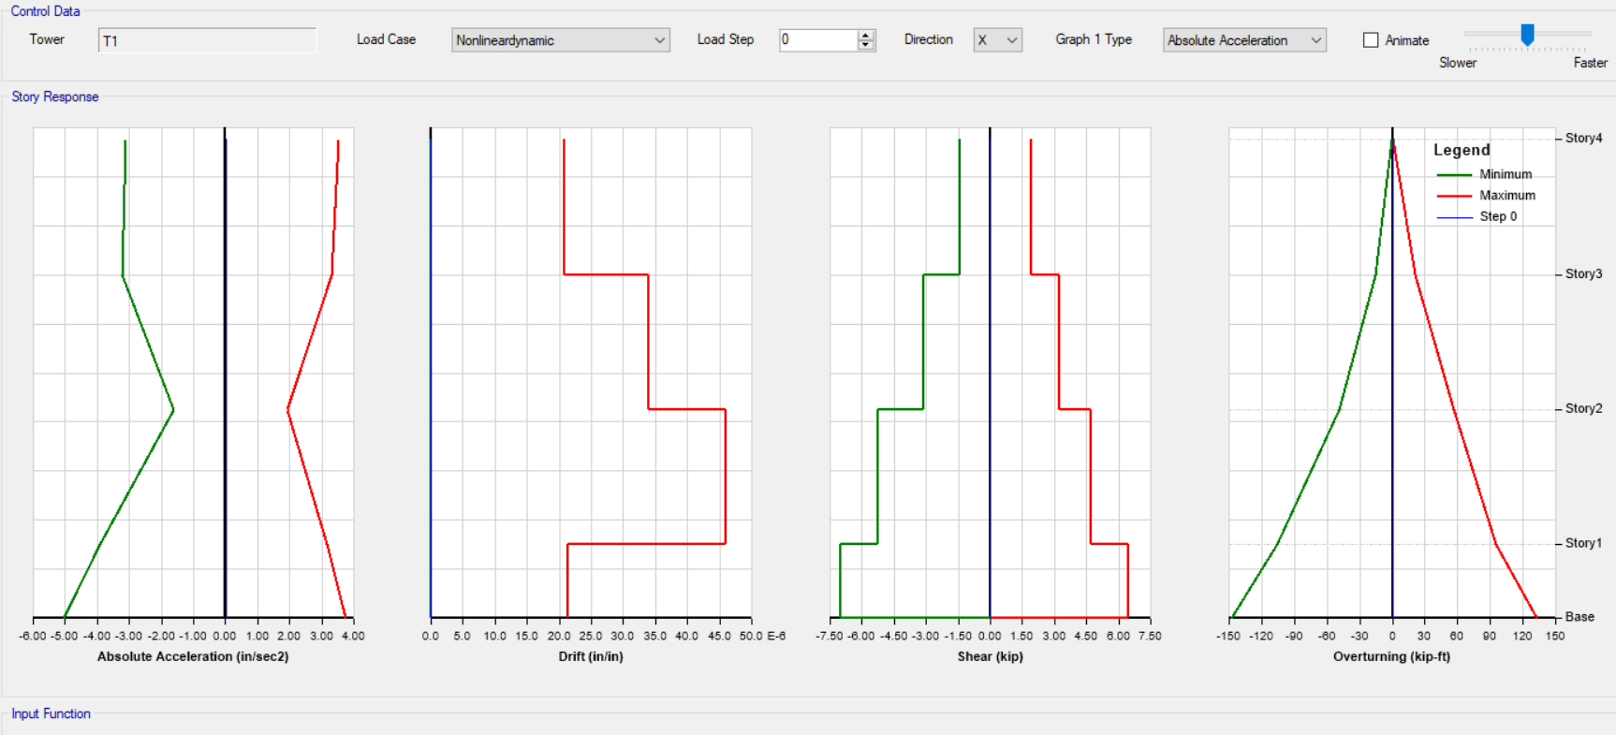
Source: Author

CHAPTER-6

EARTHQUAKE RISK REDUCTION STRATEGY

6.1 Earthquake Risk Reduction Planning Assumptions (Source: National Earthquake Contingency Plan)

- Earthquakes are impact type events and provide no warning preventing any pre-event response activities.

ii) Earthquakes within Dhaka city is going to cause large numbers of deaths and injuries and extensive damage and destruction of buildings, emergency facilities and infrastructure.

iii) There is likelihood of secondary effects following an earthquake or aftershocks which may include tsunami, fire, flood, liquefactions, subsidence, damming of rivers, landslides, and dam failure, release of hazardous and toxic chemicals.

iv) Strong aftershocks are going to be continued for several days resulting in further building collapse.

v) Large number of persons (hundreds of thousands) are going to be in needs of shelter, welfare, relief assistance, medical care etc.

vi) Access is going to be severely restricted due to debris, landslides, collapsed bridges etc.

6.2 Intended Users of the Earthquake Risk Reduction Plan

6.2.1 First Responder Institutions/Organization (Source: National Earthquake Contingency Plan). Following agencies are identified as First Responder Institution/Organizations:

i) Armed Forces Division
ii) Fire Service and Civil Defense
iii) Director General of Health Services
iv) Disaster Management Bureau
v) Department of Relief and Rehabilitation
v) City Corporations

6.2.2 Second Level Responder Institutions (Source: National Earthquake Contingency Plan).

i) Utility and Life Line Institutions (water supply, electricity, gas supply, telecommunications, waste disposal etc).
ii) Transportation systems (road, air, rail, and sea).
iii) Para military forces and Police

6.2.3 Third Responder Organizations
i) Ministries
ii) Departments
iii) City authorities
iv) Non-Government Organisation
v) Community Based Organizations
vi) Civil Society Organizations
vii) Academia etc

6.3 Earthquake Risk Reduction Plan Implementation Strategies. The following strategy to be adopted in earthquake risk reduction plan implementation:

i) A system to be set up for regular reporting and updates on the readiness of first responder institutions.

ii) Plan and Development of national capabilities to translate earthquake risk reduction into preparedness and Response Plans.

iii) Propose a mechanism to build the capacity of government and nongovernment partners by providing training and education on earthquake risk reduction.

iv) Transfer knowledge and state of the art of technologies necessary to support institutional operations and implement operations plans.

v) The plan requires that the National Emergency Operations Center is to be established on priority basis to have service functions for a 24/7 schedule with duty officers in place with clearly identified notifications protocols.

6.4 Concept of Operations

6.4.1 General Operations. It has been identified that the North Eastern and South Eastern regions of Bangladesh are vulnerable to earthquake (Bangladesh Disaster Risk Management Profile 2006).

6.4.2 Operations Principles.

i) Pre- Earthquake Phae-Disaster Management Bureau in Lead Role. The Disaster Management Bureau is going to play a lead role in the pre-earthquake phase in coordinating and ensuring preparedness of first responder organizations for effective management of response activities in partnership with other stakeholder agencies.

ii) During/Post Earthquake Phase – Armed Forces Division. During Earthquake the Armed Force Division is going to take the lead role in responding to the emergency situation. The main function of Search and Rescue of victims to be handled by Armed Forces Division with support from Fire Services and Civil Defence. Para military forces, Police, Community first responders to assist the professional search and rescue personnel employed by Armed Forces Division including Fire Services and Civil Defence.

6.4.3 Capacity Assessment

i) The shortfalls in existing capacities for responding to the needs during the disaster situation to be tied to a scenario-based assessment and can be analysed only after vulnerability of existing structures including gas, water and electricity.

6.5 Urban Services Development/Restoration

6.5.1 Objective

i) Identification of critical public facilities vulnerabilities and strengthening the same to a higher safety level.
ii) Spatial Planning and land use control for earthquake vulnerability reduction
iii) Building Control and ensure compliance to Building code practices

6.5.2 Spatial Planning. When a spatial planner receives a model showing that a magnitude 6.9 earthquake on the Madhupur Fault is going to collapse structures on Dhaka's soft, liquefied soil, they use spatial planning to fix the issue by:

i) Zoning Laws. Banning the construction of high-rises on highly liquefiable soils.
ii) Infrastructure Routing: Moving critical command centres, hospitals, and emergency supply roads into safer, seismically stable zones.
iii) Open Space Preservation: Setting aside large public parks or playgrounds that can double as safe emergency evacuation camps during a disaster.

6.6 Establishment of a National Emergency Operation Centre

6.6.1 Objectives. The objectives of the National Emergency Operation Centre is going to be as shown below:

i) Ensuring readiness among various agencies for anticipated Earthquake.
ii) Provide Technical Assistance to institutions for plan development review and revisions.
iii) Monitoring of reporting of the readiness by various first responder institutions

6.6.2 Organization Structure

i) Planning Desk
ii) Operation Desk
iii) Logistics Desk
iv) Administration and Logistics

6.6.3 Roles and Responsibilities of Various Desks. National Emergency Operation Centre is going to work 24x7. The National Emergency Operation Centre is going to work during peace and disaster time with all capacities.

Figure 6.1 Organizational Structure for National Emergency Operation Centre
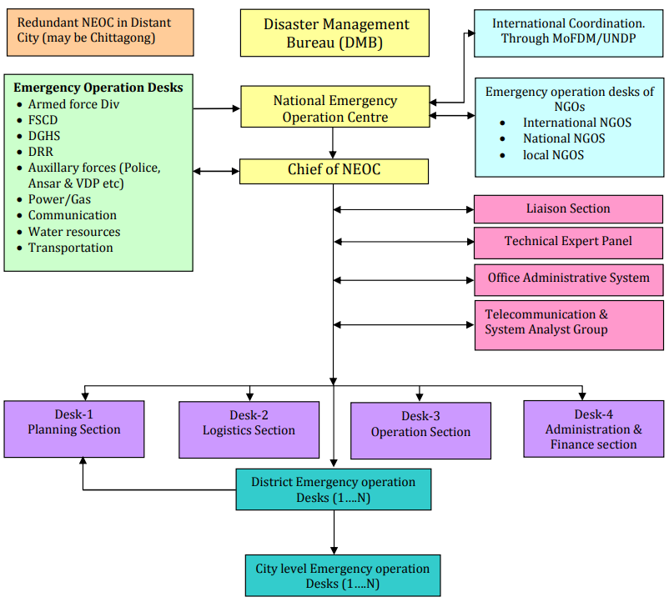
Source: National Earthquake Contingency Plan

Figure 6.2 Emergency Operation Centre
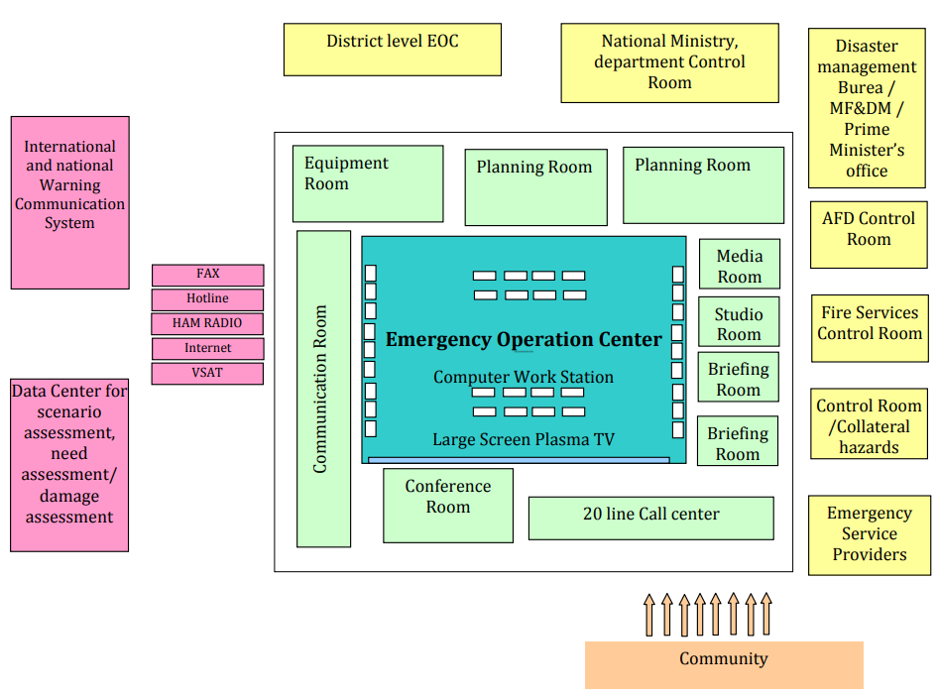
Source: National Earthquake Contingency Plan

Figure 6.3 Roles and Responsibilities of National Emergency Operation Centre

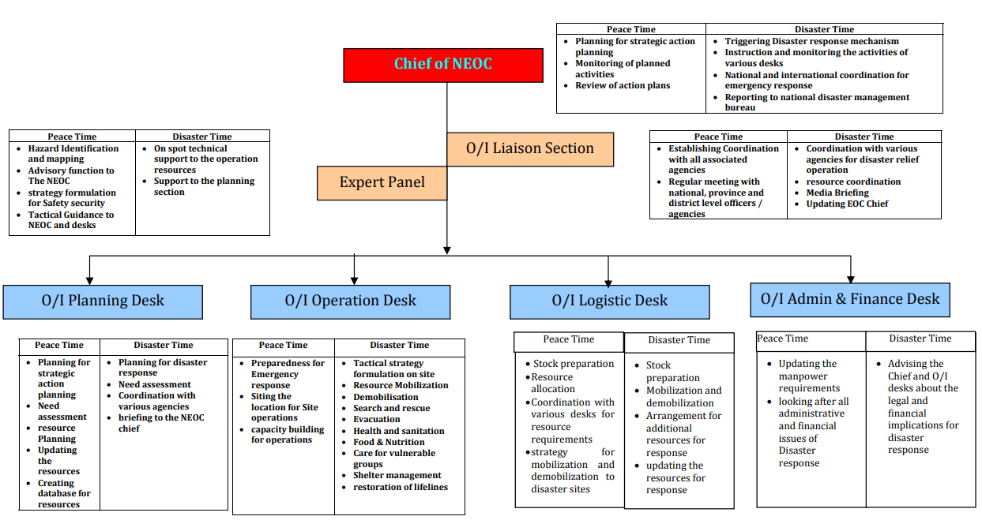
Source: National Earthquake Contingency Plan

6.7 Establishment of Reporting System for Reporting the Readiness of Different Agencies. During the plan development stage each and every first responder agency should agree to provide a bi-annual report to the National Emergency Operation Centre about the preparedness level. Each agency to minimum provides information on:

i) Whether the staff within the agency is familiar with of the Earthquake risk reduction strategy.
ii) Orientation and Training for Earthquake Risk Reduction Strategy.
iii) Understanding of each relevant officer.
iv) The vulnerability assessment of buildings.
v) Earthquake Precautionary measures and procedures.
vi) No of Building which were strengthened to have standard of safety.
- The vulnerability assessment of gas, electricity and water supply line.

6.8 Virtual Earthquake Engineering University. The virtual Eartquake Engineering University is being launched which is named as ‘Bangladesh Earthquake Engineering University’. The details are in Chapter 8.

6.9 Gas Sector Efficiency Improvement and Carbon Abatement Project. Installation of Smart Prepaid Gas meter for Titas Gas is under process where 11 lakh smart prepaid gas meter to be installed. The project estimated cost is 3542.71 crore taka. The duration is January 2024 to December 2928. The area of the project is Dhaka Distribution Division (North), Gazipur, Mymensingh. The Project being approved in Ecnec in last 31 Oct 2023.

CHAPTER 7

DISCUSSION

7.1 Faults and Major Earthquake in Bangladesh. Bangladesh sits over a complex network of active fault lines, notably the Madhupur Fault in Central Bangladesh and the Dauki Fault system in Sylhet. Between 1869 and 1930, the country experienced five major earthquakes that exceeded a magnitude of 7.0 on the Richter scale.

The most destructive historical event was the Great Indian Earthquake of 1897. This 8.7 magnitude tremor caused catastrophic losses in Dhaka, Sylhet, Mymensingh and Rangpur. More recently a 5.7 magnitude earthquake on November 21, 2025, with its epicenter in Narsingdi, killed 10 people, injured over 461, 50 buildings were destroyed across the country.

Seismologists state that these recurring minor to moderate tremors are clear indicators of stress accumulation along major underground faults.

7.2 High Risk Areas and the Threat to Dhaka. According to the official seismic zoning map of Bangladesh, the country is spilt into distinct zones of risk:

7.2.1 High Risk (Zone I): The northern and northeastern regions, including Sylhet, Rangpur and Dinajpur are highly unstable due to their proximity to the active Dauki Fault and the Himalayan front.

7.2.2 High Density Risk (Zone II): The central region, which includes the Dhaka metropolitan area, falls under a major risk zone due to the nearby Madhupur Fault.

7.3 What is going to Happen in Dhaka.

A comprehensive survey conducted by the capital’s development authority, Rajdhani Unnayan Katripakkha in 2003, reveals an alarming scenario. If a 6.9 magnitude earthquake strikes Madhupur Fault near Tangail, approximately 865,000 buildings in Dhaka could collapse. If this occurs during the daytime, it is projected to cause 210,000 deaths and 229,000 injuries.

The total economic damage is estimated at Usd 25 billion(Tk 2.62 trillion), with an additional Usd 44 billion required for rebuilding. Even a distant 7.1 magnitude quake on the Dauki Fault in Sylhet would collapse over 40,000 buildings within Dhaka city due to the fragile state of its soil and structures.

7.4 Major Concerns-Dhaka at Risk

7.4.1 Housing Regulation and Maintenance. The primary factor driving Bangladesh’s high vulnerability is the widespread disregard for safety regulations. The institute for Planning and Development notes that urban centers face extreme risks because building codes, master plans and land use zoning are routinely ignored.

7.4.2 Illegal Expansion and Weak Ground. Over 80% of buildings in the capital lack proper clearance from Rajuk and 60% of approved buildings were constructed by violating their original structural designs. Many are built illegally on filled up wetlands and marshy tracts that suffer from severe soil liquefaction during a tremor.

7.4.3 Soft-Storey Structures. Thousands of buildings use the ground floor entirely for car parking without installing reinforced concrete shear walls. These “soft stories” easily pancake under horizontal seismic forces.

7.4.4 Maintenance and Fire Risk. Most high rise buildings lack standard fire safety measures, escape routes, or regular structural maintenance, creating a secondary hazard environment where gas and electrical line explosions would follow any tremor.

7.5 Expert Opinions on Structures and Prevention
7.5.1 Structural Condition Assessment
The late Professor Jamilur Reza Choudhury, a prominent construction and earthquake expert, in his lifetime repeatedly warned that a large percentage of buildings in Dhaka flouted the building construction rules, placing millions of lives at risk.
Professor Mehedi Ahmed Ansary (2019) from the Department of Civil Engineering at the Bangladesh of Engineering and Technology emphasized that nearly 90 percent of older structures in the capital completely bypassed modern seismic design codes. Fe points out that the unchecked boom of high-density housing has left no space between buildings, which is going to cause a domino effect of collapses and block narrow roads, making rescue operations impossible.

7.5.2 Expert Advice on Prevention. To avoid a mass casualty catastrophe, urban planners and structural engineers recommend immediate, legally binding steps:

- Independent Regulatory Authority. Professor Ansary advises that the government must establish a dedicated urban planning and building safety authority that operates independently of bureaucratic and real estate developer influence.

- Mandatory Retrofitting and Enforcement. Old, highly vulnerable buildings must be reinforced using modern engineering practices or demolished. The Bangladesh National Building Code must be strictly enforced for all new construction.

- Adapting Seismic Isolation Technology. Adapting Seismic Isolation Technology. Experts suggest transitioning toward advanced construction methods like “base isolation” a system using rubber lead bearings under foundations to absorb seismic shocks. Important public structures, select metro rail stations and new power generation centers in Bangladesh have already begun incorporating this technology.

- Community Readiness. The government must fast track the creation of dedicated urban emergency shelters and cultivate public awareness through regular drills. Currently, the ministry of Disaster Management and Relief has identified 445 safe shelters across Dhaka and to create a database of 100,000 local volunteers to assist in post disaster rescue.

7.6 Infrastructure/Soil Condition in Dhaka if Earthquake Occurs
National Earthquake Hazards Reduction Program (Nehrp) has developed a site classification system representing the soil types and classes. It is an internationally well-established site classification to date.
Table 7.1: Site Classification
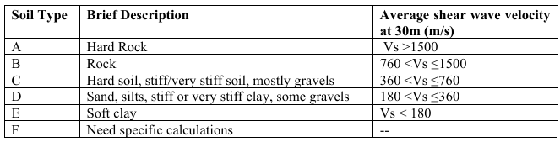
Source: National Earthquake Hazards Reduction Program

All the 87 borehole locations were analyzed, as shown above. The results are as follows:

Table 7.2: Soil Condition in Dhaka City

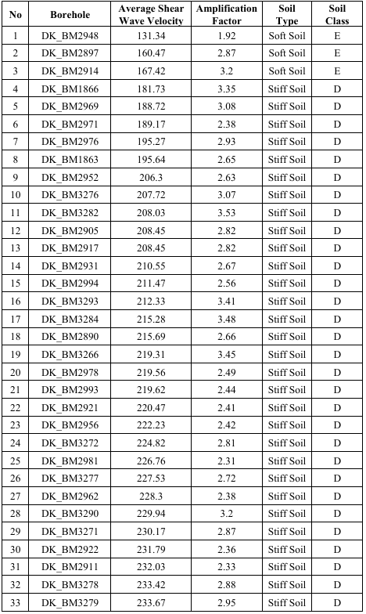

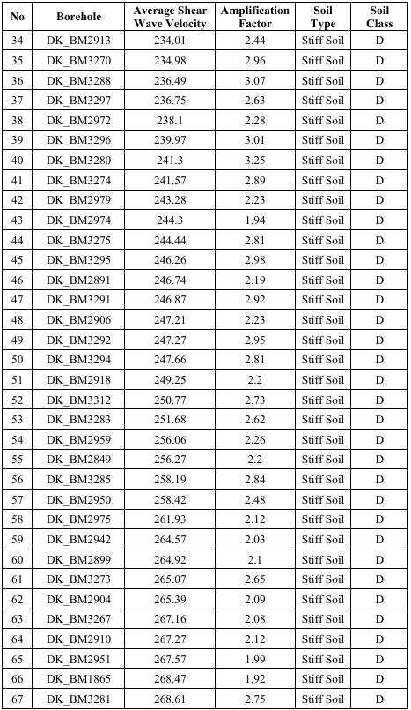
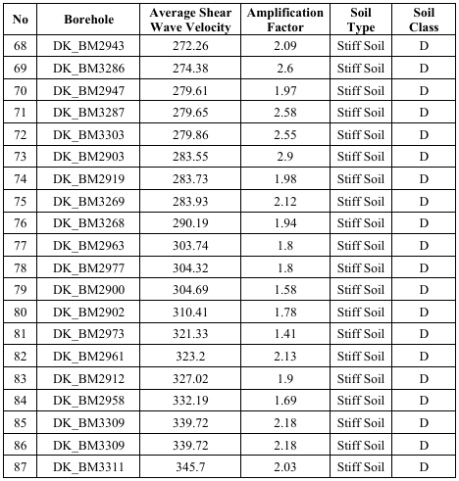
Source: National Earthquake Hazards Reduction Program

The peripheral areas of Dhaka once were water bodies, wetlands and flood plains land. Due to rapid growth and urbanization, the khals, canals, and water bodies were changed into urban areas. It was found that most of the area of Dhaka city can be classified as D according to Nehrp soil classification (Table: 7.2). Only three locations were found as E where the average shear wave velocity was below 180 m/s.

Figure 7.1: Amplification Factor Map of Dhaka

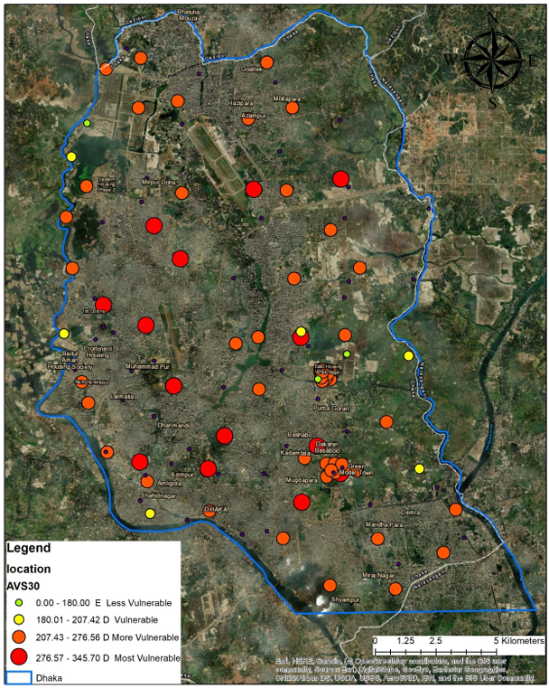
Source: A Japan-Bangladesh Joint Research Project

The peripheral areas of Dhaka are more vulnerable in terms of shear wave velocity. It happened because of landfilling, which was previously low land and wetland, and developed without proper maintenance of rules and regulations, making the areas more vulnerable to seismic hazards and disasters
Figure 7.1, for which the amplification factors are interpolated to grids in Dhaka city area, shows that some of the peripheral areas of Dhaka are more vulnerable in terms of amplification factors, making the areas more vulnerable to seismic hazards and disasters. It shows that some parts of the north-western region of Dhaka are most vulnerable; in the late 80’s it was primarily wetlands. It is also applicable for the eastern part and south-eastern part of Dhaka. The amplification factor also shows that Dhaka's areas are not evenly distributed in terms of soil amplification.
The central part of this city consists of upper, middle, and lower Madhupur terraces. The peripheral areas have consisted of high floodplains and low floodplains with wetland, marshland, and water bodies. Over the year, to manage the enormous population pressure, Dhaka started expanding towards the peripheral areas. Land development turned into a necessity for the inhabitants as well as for the government. Unplanned development without monitoring made this city seismically more vulnerable. After analysing 87 borehole data, it was found that the soil type of Dhaka is ‘D’ according to the Nehrp soil classification system. On the other hand, the amplification factor of this city is also considered very high. Especially the eastern part, north-western part and some portions of the western part are considerably high amplifiable areas. More in-depth studies in the geotechnical area are required for more accurate and reliable results from academicians and professionals.
The stratified areas showing some of the areas are vulnerable, and some are less vulnerable, but the average value indicating the amplification situation is not safe enough for generalization. There needed the most crucial intervention for making the planning rules and regulations for Dhaka.

7.7 Vulnerability assessment of critical and essential infrastructures in Dhaka (Findings of the Urban Resilience Project) :

- Rapid Visual Assessment (RVA) done for total number of buildings=3252
- Preliminary Engineering Assessment (PEA) done for total number of buildings=579
- Detail Engineering Assessment (DEA) done for total number of buildings=187
- Total number of buildings (Schools, Colleges and Hospitals) should be retrofitted= 187 and
- Total number of buildings (Schools, Colleges and Hospitals) should be demolished= 42
7.7.1 The detail engineering assessments of the structures which were carried out are to be retrofitted. This implies that structures which are detail analyzed are weak in strength below the standard.

7.7.2 Total Building vulnerability due to Madhupur fault, M 6.9:
- 864,619-1,391,685 (40%-64%) of the 2.15 million buildings

7.7.3 The Urban Resilience Program is a ground-breaking project that:

- Assessed the vulnerability of essential infrastructure, public facilities, and lifelines to better guide future investments in retroﬁtting.

- Equipped national and local disaster risk management agencies with relevant response resources, including emergency operation centers, communication systems, and related training.

- Improved construction practices by integrating disaster risk into development planning and zone processing.

7.8 The primary reasons identified for building vulnerability

7.8.1 Soft-Storey Defect. Many multi-storey residential and commercial buildings feature open ground floors used for parking or retail. These ground floors lack shear-resisting walls, making them highly flexible and prone to collapsing under seismic pressure.

7.8.2 Plan and Vertical Irregularities. Buildings often feature asymmetric mass distribution, geometric irregularities, and uneven layouts. This produces hazardous torsional twisting and uneven stress concentrations during earthquakes.

7.8.3 Substandard Construction Materials. The widespread use of poor-quality concrete mixtures, low-grade rebar, and weak mortar significantly compromises a building’s baseline structural load-bearing strength.

7.8.4 Failure of Non-Structural Elements. Modern facades, heavy glass cladding, false ceilings, and poorly anchored partition walls are highly unstable. They pose severe risks of collapsing outward into narrow streets.

7.8.5 Construction on Unstable Filled Land. Massive migration has forced rapid urban expansion onto filled-up canals, low-lying wetlands, and floodplains. This soft soil significantly exacerbates the risk of liquefaction, soil settlement, and foundation tilting during earthquakes.

7.8.6 Aging Infrastructure. A vast percentage of urban housing consists of buildings that are 30 to 40 years old. These structures have deteriorated over time and lack the foundational engineering required to withstand modern seismic activity.

7.8.7 Violation of Approved Designs. Developers frequently deviate from officially approved architectural blueprints to maximize floor space. This adds uncalculated weight that overburdens the structural foundations.

7.8.7 Low Adherence to Building Codes. While the Bangladesh National Building Code mandates earthquake and fire-resistant standards, enforcement mechanisms historically remain opaque and lack direct accountability.

7.8.8 Inadequate Quality Control. Construction processes lack standardized on-site verification, leading to common operational issues like poor concrete curing, inadequate compaction, and weak joints.

7.8.9 Extreme Building Proximity. Due to a lack of setback space, buildings are constructed directly adjacent to one another. This increases the likelihood of a "domino effect" structural collapse and prevents safe emergency evacuation.

7.9 Urban Planning Strategies and Policy Framework to Make Dhaka City Resilient against Earthquake

7.9.1 Visioning Seismic Resilient City. Ultimate vision of this endeavour is to gradually develop efficient and effective urban planning strategies to make cities safer and more resilient against earthquake. Pursuing of this vision is not an isolated work, it needs multi-stakeholders’ efforts. Following interventions are extremely necessary to make Dhaka city resilient:

- Seismic hazard responsive land use planning and enforcement of that plan;
- Construction of seismic responsive buildings in compliance with building construction rules and code;

- Evaluation of the building distribution by seismic performance in the city;

- Prioritization of public and private building for retrofit;

- Knowledge sharing with community about community resilience and retrofitting;

- Strong integrated effective disaster risk governance (Legal, Institutional, and Execution);

- Resilience oriented investment of resources to make city safer and resilient.

Figure 7.2: Vision of Building Earthquake Resilient City

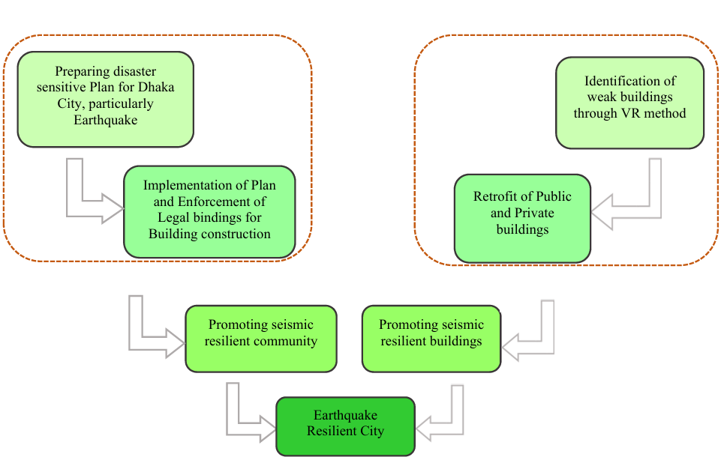

Source: Guidebook on Towards Seismic Resilience in Dhaka City: An Urban Planning Perspective

A long-term endeavor that city authorities and the citizen must pursue with combined efforts keeping a vision ahead for earthquake resistant city. The schematic diagram (Figure 7.2) shows us the process of developing an earthquake resilient city in comprehensive manner.

7.10 The Fields Where to Focus for Building Seismic Resilient City.

Development of efficient and effective urban planning strategies to make cities safer and more resilient against disasters

7.10.1 Earthquake Responsive Urban Planning City development authority need to consider all the shocks and threats related to earthquake in the city including seismic fault lines, geology, land formation and soil condition of the city. Plan must be prepared on the considering the finding of the above-mentioned investigation to reduce the seismic vulnerability of Dhaka city. Geological matters in urban planning to be taken into consideration.
7.10.2 Enforcement of Formulated Plan and Policy. The formulated policy is enforced to be complied.

7.10.3 Building distribution of seismic performance. As a part of improving seismic resilience of the city, chapter 3 of this guidebook guides through a process developing a method for identifying the buildings with low seismic performance using Japanese Standard. The method of estimating seismic performance helped in addressing ‘building condition’ in understanding the city’s overall seismic condition.

7.10.4 Prioritization of Building for Retrofit. For improving seismic resiliency of Dhaka city, it is required to improve seismic performance of the buildings through seismic retrofitting. Random selection of buildings for seismic retrofitting might not help in achieving efficiency. Buildings should be prioritized for retrofitting to maximize efficiency as a part of improving seismic resiliency.

7.10.5 Compliance of Building Rules and Code. Building rules and code should be complied.

7.10.6 Revision of Contingency Plan. Earthquake Contingency Plan was prepared in 2009 under the Comprehensive Disaster Management Programme. It was solely prepared for the unified Dhaka city corporation to withstand the adversity of an earthquake. In this document it clearly mentioned that twenty-seven stakeholder organizations are directly related to execute the plan. However, most of the stakeholder organizations are unaware of this plan. Disowning such a plan merely indicate the lack of interest among the organizations.

7.10.7 Measures to be Taken to Improve City’s Resilience. Here is the summary of policy interventions need to be taken for building a seismic resilient Dhaka city.

Serial No | Existing Situation | Necessary Policy Intervention
1 | Building Permission Process | To reduce building vulnerability, new section should be added in the Building construction rules that structural design has to approved through Rajuk | Dynamic Time History analysis including earthquake resistant electricity,gas, water line to be attached

7.11 Earthquake Resistant Lifeline Utilities (Water, Gas, and Power). A city cannot survive an earthquake if its core lifelines are disrupted:

7.11.1 Flexible Pipeline Joints. Rather than rigid cast-iron pipes, modern water and gas networks use segmented, high-density polyethylene lines. These pipes pull, push, and bend at the joints without bursting during severe ground displacement.

7.11.2 Automated Shutoff Valves. Natural gas grids are equipped with smart seismic sensors. The moment a critical threshold of ground velocity is reached, the system automatically shuts down regional gas valves to prevent catastrophic urban firestorms.

7.12 The primary reasons identified for building vulnerability include:

7.12.1 Structural and Engineering Flaws

i) Soft-Storey Defect. Many multi-storey residential and commercial buildings feature open ground floors used for parking or retail. These ground floors lack shear-resisting walls, making them highly flexible and prone to collapsing under seismic pressure.

CHAPTER 8

ONLINE/VIRTUAL EARTHQUAKE ENGINEERING UNIVERSITY

8.1 Vision

Vision to build a successful Online/Virtual Earthquake University must combine flexible digital learning with practical, real-world simulation tools.

8.2 Operational Modalities

The key operational modalities which are required, this vision being in reality:

8.2.1 Academic & Curriculum Structure

The academic and curriculum structure is as follows:

Degree Pathways. Targeted in Offering fully accredited Bachelor’s, Master’s, and Ph.D. programs in Seismology, Earthquake Engineering, and Disaster Management.

Micro-Credentials. Short, targeted certificate, courses for working professionals like architects, city planners, and first responders.

Global Faculty Network. Hosting live and recorded lectures from top global scientists, pooling research from seismically active regions like Japan, Turkey and the United States of America.

8.2.2 Technology & Learning Methods

i) Virtual Reality Labs. Using virtual reality headsets so remote students can safely simulate structural stress tests, building collapses, and emergency rescues.

ii) Cloud-Based Modeling. Providing students access to high-powered software (like SAP2000 or OpenSees) via the cloud to design earthquake-resistant structures.

8.2.3 Hybrid & Field Partnerships

i) Local Practical Hubs. Partnership with local engineering universities worldwide so online students can complete mandatory, hands-on lab work locally.

8.2.4 Global Impact & Access
i) Open-Access Knowledge. A free, public digital library containing earthquake blueprints, survival guides, and retrofitting techniques for low-income communities.

8.2.5 Technical Software Requirement. Few open source software are:
i) Open Sees. Open-source framework for simulating how structural and geotechnical systems respond to earthquakes.
ii) Open Quake Engine. An open-source software to calculate earthquake hazard and risk globally.

8.2 Virtual Earthquake Engineering University

i) https://github.com/mohammademadulhaque/Bangladesh-Earthquke-Engineering-University

ii) An Open-Source, Global Digital Portal for Seismic Design, Structural Dynamics and Geotechnical Education.

iii) This open-access digital portal is dedicated in providing high-quality, structured and free educational resources for students, researchers, and structural engineers worldwide to design a safer, resilient built environment.

8.2.1 Academic Departments & Curriculum

i) Department of Structural Dynamics

ii) Department of Seismology & Earth Sciences

iii) Department of Seismic Design & Geotechnical Engineering

Virtual Simulation Laboratory

v) Global Research & Data Center

vi) How to Contribute to Virtual Earthquake Engineering University

Readme.md (Uploaded Files)

CHAPTER 9

CONCLUSIONS AND RECOMMENDATIONS

9.1 Conclusions
Proactive strategy required to address infrastructure security focusing earthquake. Imparting knowledge on earthquake is utmost important. Bangladesh Earthquake Engineering University is formed/launched in view with a proactive strategy. This strategy is earthquake response strategy focusing urban infrastructure security.
Base Isolation technology were searched rigorously where it was found resilient gas system is integrated with structural/architectural design. Validation of research objectives through Bangladesh National Building Code could be obtained. Structural analysis done. Through visual rating method vulnerability of existing structure were searched.
The comprehensive structural scenario of Dhaka's building stock reveals that most analyzed concrete structures suffer from structural flaws, specifically weak frames and a critical lack of ductile detailing. Buildings are at severe risk of structural pounding due to inadequate separation joints between adjacent properties.
Scenario-based seismic vulnerability analysis indicates that a magnitude 6.9 earthquake along the nearby Madhupur Fault would result in catastrophic structural failure across the capital, damaging or destroying between 40% and 64.8% of Dhaka's 2.15 million buildings.
Unplanned urban expansion has heavily altered Dhaka landscape, turning former lowlands, wetlands and canals into densely packed neighborhoods via loose, uncompacted earth filling. Geotechnical data classifies the vast majority of Dhaka soil as stiff soil/sand/clays having liquifiable characteristics. Crucially, standard pre-construction soil investigations in Bangladesh routinely fail to provide or calculate necessary liquefaction data.

While the current engineering view focuses almost exclusively on the superstructure of buildings, the seismic qualification, restraint design and automated protection of critical utility services (such as gas, electricity, and water lines) are completely neglected in standard building designs. Dhaka's underground gas network remains rigid and highly susceptible to simultaneous ruptures, having an environment primed for cascading post-earthquake firestorms.
Out of 3,252 essential municipal buildings screened via Rapid Visual Assessment, 187 high-priority structures underwent rigorous Detail Engineering Analysis. Based on final engineering metrics, 187 of these analyzed public buildings are confirmed to be structurally under-strength and require immediate retrofitting, while 42 very high-risk municipal buildings have been officially declared for demolition.
To mitigate a mass-casualty disaster, the paper notes an urgent need to transition from reactive relief planning to digitalized, proactive strategy. This structural transformation has been initiated through the launch of the open-access portal for the Bangladesh Earthquake Engineering University to deliver decentralized training, alongside Titas Gas's active deployment of smart prepaid gas meters to systematically improve energy management.
The factor of safety against earthquake-induced soil liquefaction is commonly evaluated during geotechnical investigations for sites susceptible to liquefaction. The factor of safety is generally determined as the ratio of the soil's cyclic resistance to the cyclic stress induced by earthquake loading. A factor of safety greater than 1.0 indicates that the soil possesses adequate resistance against liquefaction under the considered seismic loading. Where necessary, appropriate ground improvement measures are recommended to achieve acceptable safety levels.
Most of the soil test companies in Bangladesh do not provide the liquefaction data in soil test. In practice we calculate susceptibility to liquefaction as per code guideline for specific project as per requirement. Pile is designed considering earthquake induced lateral force and bending moment. Pile size and rebar requirement increases due to increased lateral force. Pile embedment length is increased as well.
Although provisions for the seismic design and restraint of non-structural components, including gas piping, Heating, ventilation and air conditioning systems and air-conditioning lines, are provided in ASCE 7-16 (Chapter 13: Seismic Design Requirements for Nonstructural Components), such checks are generally not carried out as part of routine building design and vetting practice in Bangladesh. Current engineering practice primarily focuses on the seismic performance of structural components, while detailed seismic qualification and restraint design of utility systems and mechanical services are not commonly implemented except in specialized or critical facilities.
Urban Resilience project surveyed 3252 important buildings composed of 5.3 million square meters, using the Rapid Visual Assessment methodology. Then 578 of the buildings prioritized in the Rapid Visual Assessment stage, composed of 1 million square meters went through Preliminary Engineering Analysis. Finally, 187 of the buildings, composed of more than 0.4 million square meters went through in-depth Detail Engineering Analysis. Out of 187 buildings 42 buildings were earmarked to be demolished.

9.2 Recommendations

9.2.1 Deploying Advanced Structural Health Systems/Monitoring Systems. In 2026, the use of smart sensors and IoT in construction is not just a trend but a necessity. These systems provide real-time data on building integrity, allowing for timely maintenance and upgrades. Consider installing seismic sensors and structural health monitoring systems for proactive safety management.

Install smart IoT sensors and continuous structural health monitoring networks. These arrays provide crucial, real-time building deformation and integrity data for proactive safety upgrades.
9.2.2 Mandate Specialized Dynamic Structural Engineering. Integrate site-specific Soil Liquefaction Analysis into standard geotechnical foundation clearances to counteract failures on filled alluvial lands. Enforce rigorous Dynamic Time History Analysis under the BNBC guidelines for all planned high-rises exceeding 40 meters in height.
9.2.3 Enforce Automated Lifeline Safeguards. Equip high-pressure gas distribution networks with automated, smart seismic shutoff valves to prevent catastrophic, cascading secondary firestorms following a structural collapse.

9.2.4 Establish a Unified Regulatory Authority. Create an independent building safety and urban planning oversight body functioning separate from bureaucratic and real estate developer pressures to stringently enforce the Bangladesh National Building Code 2020.

9.2.5 PGA Threshold Check. All structural and foundation calculations must clear the maximum scenario-based Peak Ground Acceleration surface threshold of 0.9g derived from a potential Madhupur Fault seismic event.

9.2.6 Soil Safety Factor. Foundation piling designs must explicitly prove a Factor of Safety against cyclic stress-induced liquefaction strictly greater than 1.0.

9.2.7 Routine Utility Restraints. Enforce the non-structural component restraint rules outlined in chapter 13 of ASCE 7-16 across regular urban vetting to safely anchor HVAC and utility networks.

REFERENCES
AL QURAN
Alam, M.S., Ahmed, B. and Rahman, M.S., 2018. Urbanization, megacity growth, and the evolution of seismic vulnerability in Dhaka, Bangladesh. Journal of Urban Systems and Disaster Risk, 22(4), pp. 312–329.
ACI 318 (2008) Building Code Requirements for Structural Concrete (ACI 318M-08) and Commentary. ACI Committee 318, American Concrete Institute, Michigan.
Amin, M. R., (2011) Nonlinear Seismic Analysis of Multi-Storied Reinforced Concrete Buildings with Masonry Infill, M.Sc. Engg. Thesis, Department of Civil Engineering, Bangladesh University of Engineering and Technology.
Astrid, R. F., Julian, C., and Hugo, H.B., “Analysis of the Earthquake Resistant Design Approach for Buildings in Mexico,” Engineering, Research and Technology., vol. 15 (Issue 1), pp 151-162, 2014.
BNBC (2020) Bangladesh National Building Code. Housing and Building Research Institute, Dhaka.
Chopra,A.K., (2012), Dynamics of Structures – Theory and Application to Earthquake Engineering, Fourth Edition, Prentice Hall Inc, USA
Clough, R. W., (1966) “Effect of Stiffness Degradation on Earthquake Ductility Requirements,” Structural and Materials Research, Structural Engineering Laboratory, Univ. of California, Berkeley, Report 66-16.
CSi (2015) ETABS: User Interface Reference Manual. Computers and Structures, Inc., Berkeley.
Kim, J., and Choi, H., (2005) “Response Modification Factors of Chevron-braced Frames,” Engineering Structures, vol. 27(2), pp. 285-300.
Elfath, H. A., (2019) “Evaluating the Inelastic Displacement Ratios of Moment-Resisting Steel Frames Designed According to the Egyptian Code,” Earthquake Engineering and Engineering Vibration, vol. 18, pp. 159-170.
Elnashai, A. S., and Mwafy, A. M., (2002) “Overstrength and Force Reduction Factors of Multistorey Reinforced-concrete Buildings,” The Structural Design of Tall Buildings, vol. 11(5), pp. 329–351, 2002.
Eleous, M. and Al Noman, A., 2025. Causes and remedies of building construction deviation in Dhaka Metropolitan Area regarding stakeholders’ perception: A case study. Journal of Sustainable Cities and Built Environment, 3(1), pp. 25-48.
FEMA 74. Reducing the Risks of Nonstructural Earthquake Damage: A Practical Guide; Federal Emergency Management Agency: Washington, DC, USA, 1994.
FEMA 695 (2009) Quantification of Building Seismic Performance Factors. Federal Emergency Management Agency, Washington, D.C.
Ferooz, S., 2017. Seismic vulnerability assessment of transportation networks and lifeline infrastructure in urban centers. Journal of Infrastructure Security and Disaster Resilience, 5(2), pp. 112–129.
Gunay, M. S., (2011) A Practical Guide to Nonlinear Static Analysis of Reinforced Concrete Building with Masonry Infill Walls. Computers and Structures, Inc., Berkeley.
Ilki, A., (2000) The Nonlinear Behavior of Reinforced Concrete Members Subjected to Reversed Cyclic Loads, PhD Thesis supervised by Prof. Dr. N. Kumbasar and submitted to Istanbul Technical University.
Ilki, A., Yuksel, E., Darilmaz, K., Bakan, I., Zorbozan, M., and Karadogan, F., (1998) “Prefabricated Columns Subjected to Displacement Reversals,” Seismic Safety of Big Cities, Earthquake Prognostics World Forum, Istanbul.
Japan Society of Seismic Isolator (Prospectus)
Jirsa, J. O., and Feghali, H. L., (1999) “Simulation of Seismic Response of Reinforced Concrete Structures,” in Uğur Ersoy Symposium on Structural Engineering, pp. 261-274.
Khan, A.A., Hoque, M., Akhter, S.H. and Hoque, M.A., 2001. Earthquake in Bangladesh: A natural disaster and public awareness. The Journal of NOAMI, 18(2), p. 37.
Khan, M. N., (2013) Evaluation of Seismic Performance of RC Frame Structures by Pushover and Time History Analyses, M.Sc. Engg. Thesis, Department of Civil Engineering, Bangladesh University of Engineering and Technology.
Medina, R.A., and Krawinkler, H.,(2004) “Influence of hysteretic behaviour on the nonlinear response of frame structures,” 13th World Conference on Earthquake Engineering at Vancouver, Canada.
Mohammadi, R. K., (2002) “Approximate Evaluation of Deflection Amplification Factor,” Journal of Structural Engineering, vol. 128(2), pp. 179-187.
Mollaioli, F., Mura, A., and Decanini, L. D., (2007) “Assessment of the Deformation Demand in Multi-Storey Frames,” Journal of Seismology and Earthquake Engineering, vol. 8(4), pp. 203-219.
Ministry of Housing and Public Works, 2021. Bangladesh National Building Code (BNBC) 2020. Bangladesh Gazette Extraordinary, Published by Authority. Dhaka: Government of the People’s Republic of Bangladesh.
Nowroz, S., 2003. The vulnerabilities and risk of earthquake in Bangladesh including mitigation/management measure. Journal of Disaster Management and Structural Safety, 1(2), pp. 45-62.
Ottosen,N.S., and Ristinmaa,M.,(2005), The Mechanics of Constitutive Modeling, First Edition, Division of Solid Mechanics, Lund University, Sweden
Public Works Department (2021) Manual for Seismic Design of Reinforced Concrete Buildings. 2nd edn. Dhaka: Public Works Department, Bangladesh.
Samimifar, M., Oskouei, A.V., and Rofooei, F. R., (2015) “Deflection Amplification Factor for Estimating Seismic Lateral Deformations of RC Frames,” Earthquake Engineering and Engineering Vibration, vol. 14, pp. 373-384.
Uang, C. M., and Maarouf, A., (1994) “Deflection Amplification Factor for Seismic Design Provisions,” Journal of Structural Engineering, vol. 120(8), pp. 2423-2436.
Uang, C. M., (1991) “Establishing $R$ (or $R_{w}$) and $C_{d}$ Factor for Building Seismic Provision,” Journal of Structural Engineering, vol. 117(1), pp. 19–28.
www.researchgate.net/publication/328571852_Seismic_Evaluation_and_Retrofi_t_of_Existing_Tall_Buildings_in_California_Case_Study_of_a_35-Story_Steel_Moment-Resisting_Frame_Building_in_San_Francisco/figures?lo=1

